**How to Import Course Content**

Follow the instructions below to import content into your previous course.

1. Click to open the course you want to import into (your current course shell)

2. Click on the **MAROON** button *Course Management* icon at the top/center of the Moodle page

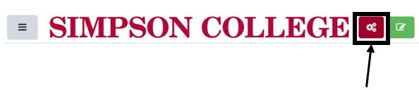

3. In the *Course Settings* column, click on **Import**.

4. Click on the dot to the left of the course you want to import from (i.e. last years course).

5. Click **Continue**.

6. Click **Next** (on the Import settings page).

7. Glance down through the list on the page to make sure you want to import everything.

8. Click **Next**(the Import settings page will just recap what you have chosen to import).

9. Click **Perform Import**.

Once the import is finished, everything from your previous course will be added to the new (current) course shell.