**How to Show/Hide a Course in Moodle**

*What if you have a student who needs to access work from a past course, you can use these instructions to open up the course, and then close it again once the student has accessed what they need.*

To Show or Hide a course, follow the steps below.

1) Access the course in Moodle that you would like to show or hide.

2) Click on the **Course Management icon** (maroon button at the top of the page).

3) Choose **Edit course settings** located under the *Course Settings column*.

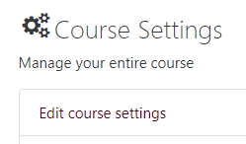

4) Scroll down under the General section and change the Course visibility drop-down to be **Hide** or **Show**.

Image showing course visibility settings

5) Then, scroll to the bottom of the page and click **Save and display.**