**How to Upload a Video in Moodle**

1. From the Moodle textbox, click on the green Panopto icon located in the text toolbar.

2. Click on the Upload option in the center of the Panopto upload window.

3. Click the arrow located at the top right of the Panopto upload window to open the drop-down options.



4. Scroll down to Moodle Provisioned Courses and **click on the arrow** located to the left of the **Moodle Provisioned Courses** text. 

5. Locate the name of the Moodle course where you would like to add the video.

**INSTRUCTORS:** Click on the name of the Moodle course, 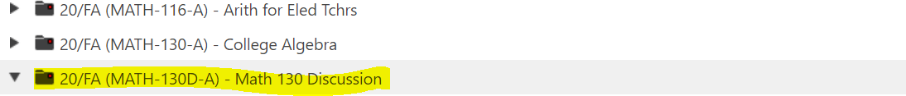

**STUDENTS:**  
1) Click on the arrow beside the name of the Moodle course,  
2) Click on the (assignments) folder link.

6. A drop box will appear in the Panopto window where you can drag and drop your video.

7. After the video has uploaded, click on the **Insert** button located in the bottom left-hand corner of the Panopto window.

8. Once the video appears in the Moodle textbox, scroll to the bottom of the page and click Post to the forum, Save, Submit, etc.

