**Moodle Instructor Dashboard  
*Intelliboard Data***

The Instructor Dashboard, located within the Moodle platform, allows anyone in a Teacher role access to user-friendly data about their Moodle course . To access the Instructor Dashboard, follow the steps below.

1. Click on the hamburger (3 lines) located at the top left corner of any Moodle page.  
   2) Click on the tab labeled Instructor Dashboard.   
   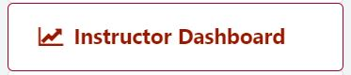
2. Once you are on the Instructor Dashboard, use the tabs below to learn about and navigate the various monitors and reports available.

**Dashboard**

The Instructor Dashboard tab is split into three sections. Descriptions about each section can be found below.   
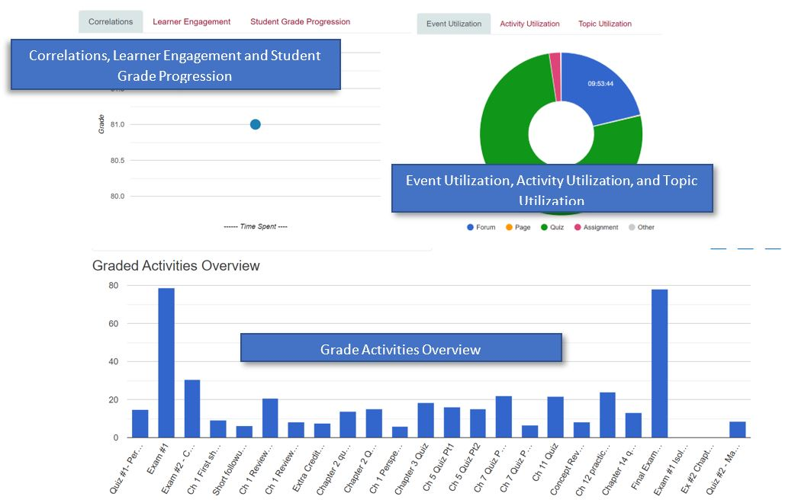

CORRELATIONS, LEARNER ENGAGEMENT, AND STUDENT GRADE PROGRESSION

|  |  |
| --- | --- |
| Intelliboard Correlations Graph image | **CORRELATIONS:** This correlation graph shows the relationship between the average grade for the course against learner total time spent. The vertical axis displays the average grade; the horizontal axis displays total time spent.  Hover over a dot for a tool-tip providing the average grade and the time spent on course |
| Intelliboard Learner Engagement Graph image | **LEARNER ENGAGEMENT:** This graph displays the percent of students engaging in an activity during a selected time period in a chosen course.  Activities are displayed along the horizontal axis. The percentage of students engaging in the activity is displayed along the vertical axis. Hover over a data point for additional details. |
| Intelliboard Student Grade Progression Graph | **STUDENT GRADE PROGRESSION:** This graph displays the relationship between the average grade for the course against learner course grade. The vertical axis displays learner's course grade (in percent); the horizontal axis displays the date when the grade was taken. Hover over a dot for a tool-tip providing the learner's grade and the average grade on the date. |

EVENT UTILIZATION, ACTIVITY UTILIZATION, AND TOPIC UTILIZATION

|  |  |
| --- | --- |
| Intelliboard Event Utilization Graph | **EVENT UTILIZATION:**This pie chart displays the amount of time your learners are spending in your courses.  Hover over the different sections for a tool-tip providing the percentage as well as the total amount of time (hh:mm:ss). The key is at the bottom.  If there is a blue triangle, additional values exist and you should click the blue triangle. |
| Intelliboard Activity utilization graph | **ACTIVITY UTILIZATION:**This pie chart displays the amount of time your learners are spending in activities in a selected course during a selected time period (hh:mm:ss, hours:minutes:seconds). Hover over each segment for additional details. |
| Intelliboard Topic Utilization Graph | **TOPIC UTILIZATION:**This pie chart displays the amount of time your learners are spending in topics in a selected course during a selected time period (hh:mm:ss; hours:minutes:seconds). Hover over each segment for additional details. |

GRADED ACTIVITIES OVERVIEW

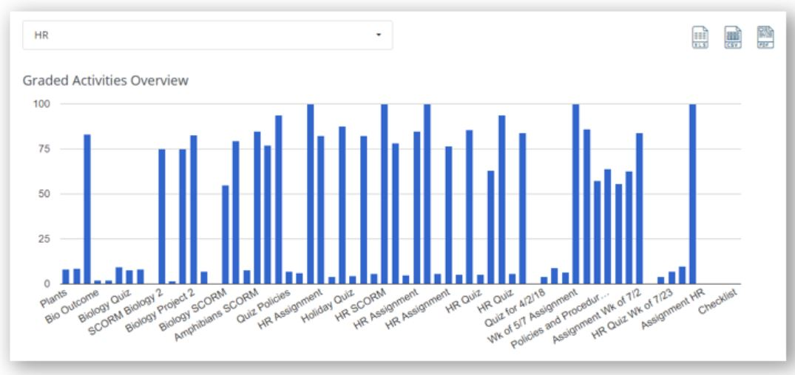

This bar graph displays average grades of activities in the selected course.  The blue bars represent the average grade of activities.  Hover over a bar for a tool-tip providing the activity name and the average grade of activities.

Export this graph in needed format by XLS, CSV or PDF doc button in the top right corner of the graph.

**Courses**

The Courses tab allows instructors to view and compare statistics about all of their courses on the same page. For more information and instructions on how to navigate the Courses tab, please see below.   
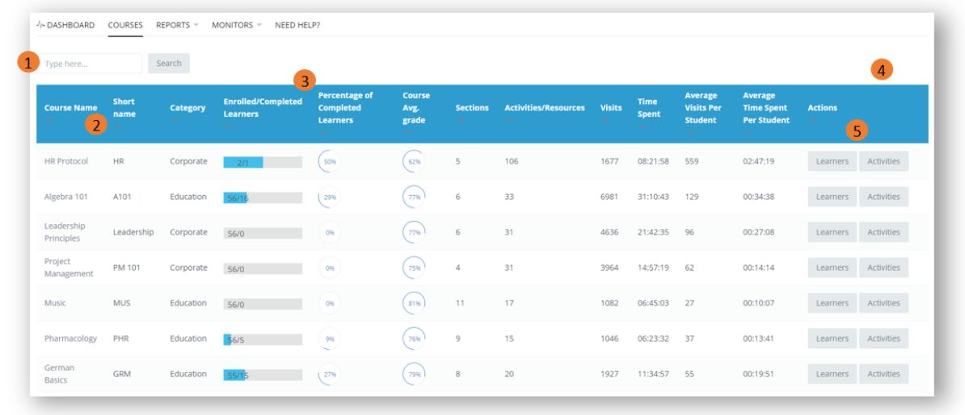

1. Search Bar: Type a search term in the search bar and click "Search" to filter the report by search term.   
2. Remove/Add Columns: Click the "-" button after any Column Header to remove the column; click the "+" button to add the column.  
3. Columns: Click the Column Header to sort data in that column.  
4. Reset Table Preferences: After manipulating any part of the report, a blue "Reset table preferences" link will appear.  After clicking this link, the full report will reappear.   
5. Actions: Clicking the buttons "Learner" or "Activities" will pull up additional information. Review report details after the Course Column Overview.

Learners button  
At the far right-hand side of the Course Tab, you will see the Learners button.   
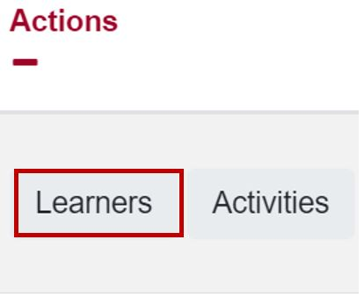  
Click on the Learners button, you will be taken to a page that looks like the snippet below.  
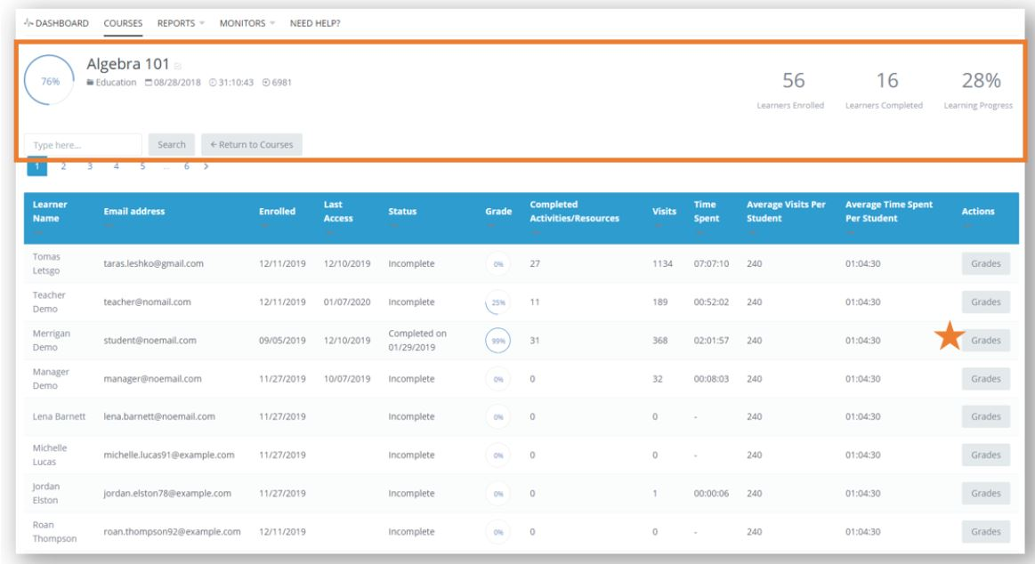  
This report displays specific information about each learner in your course. A few of the displayed columns include user name, email address, current grade, visits to the course, time spent in Moodle, average visits per student and more.

Clicking on the Grades button (at the far right) will allow you to dive deeper into individual activity grades for an each student.

Activities button  
At the far right-hand side of the Course Tab, you will see the Activities button.  
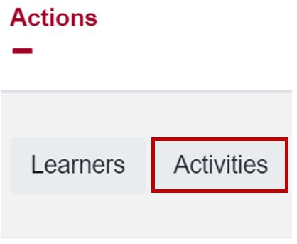  
Clicking on the Activities button gives you specific information about each activity in your course. You can filter the report by activity type and by individual modules too. You can view a screenshot of this report below.   
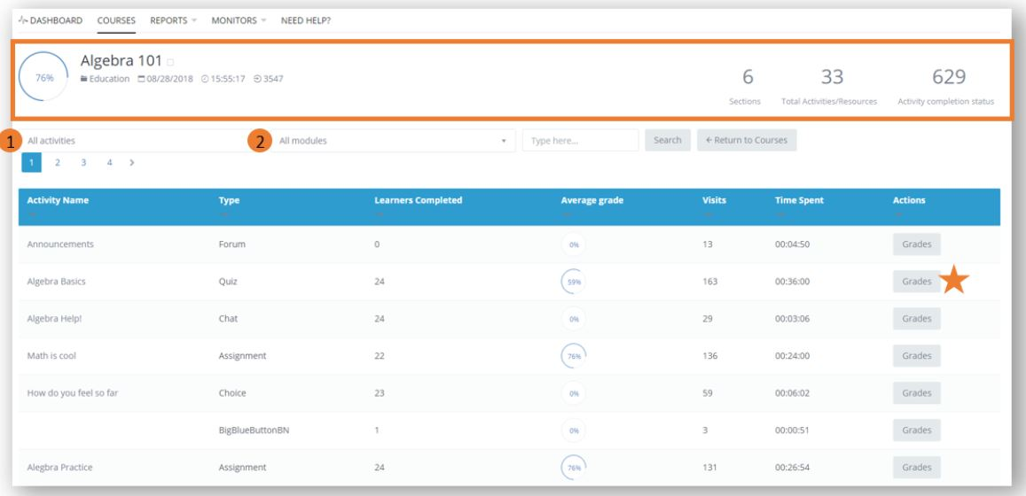  
1. Filter the report by activity type (all activities or custom)  
2. Filter the report by modules

Clicking on the Grades button (at the far right) will allow you to dive deeper into the grades for individual activities.

**Reports**

The Reports tab provides a list of reports available. View the table below to learn more about the report options from Intelliboard using your Moodle data.

|  |  |
| --- | --- |
| **Report Name** | **Report Description** |
| **Intelliboard Time Tracking Table Intelliboard Time tracking Table image** | This report displays user's time spent on each page, access points, and IP information. (*User Name, email, Visits, Time spent, First/Last access, Browser, OS, IP address)*  [**https://support.intelliboard.net/hc/en-us/articles/360025951292--IntelliBoard-Time-Tracking-Table-odle-LMS-**](https://support.intelliboard.net/hc/en-us/articles/360025951292--IntelliBoard-Time-Tracking-Table-Moodle-LMS-) |
| **Access Stats by Course Intelliboard Access stats by course report image** | This report displays the most active times of the day as well as the amount of access time per weekday organized by course.  [**https://support.intelliboard.net/hc/en-us/articles/360012560631-Access-Stats-by-Course-Moodle-LMS-**](https://support.intelliboard.net/hc/en-us/articles/360012560631-Access-Stats-by-Course-Moodle-LMS-) |
| **Activity Stats Summary** Intelliboard Activity Stats Summary report image | This report displays cumulative data for each activity used within a course. *(Visits, Time spent, Average Score, Created, First Access, Course)*  [**https://support.intelliboard.net/hc/en-us/articles/201118909-Activity-Stats-Summary-Moodle-LMS-**](https://support.intelliboard.net/hc/en-us/articles/201118909-Activity-Stats-Summary-Moodle-LMS-) |
| **Course Inactivity Intelliboard Course Inactivity Report image** | This report displays users who have not logged into the course within a specified date range. *(Course, User name, email, Enrolled date, Grade, Last Access date)*  [**https://support.intelliboard.net/hc/en-us/articles/206219246-Course-Inactivity-Moodle-LMS-**](https://support.intelliboard.net/hc/en-us/articles/206219246-Course-Inactivity-Moodle-LMS-) |
| **Learner Compared to Course Average** Intelliboard Learner Compared to Course Average image | This report displays a specific learner against the average for all learners enrolled in the course. This analytic is frequently used to identify at-risk learners. *(Interactions, Course access, Submissions on quizzes and assignments, Total time spent in course, Course score)*  [**https://support.intelliboard.net/hc/en-us/articles/206770866-Learner-Compared-to-Course-Average-Moodle-LMS-**](https://support.intelliboard.net/hc/en-us/articles/206770866-Learner-Compared-to-Course-Average-Moodle-LMS-) |
| **Learner Forum Participation Summary** Intelliboard Learner Forum Participation Report | This report is used to evaluate learner participation within specific forums. *(Bar chart showing forum usage days/times, Forum name, User name, Course, #  Discussions, # Posts)*  [**https://support.intelliboard.net/hc/en-us/articles/206238976-Learner-Forum-Participation-Summary-Moodle-LMS-**](https://support.intelliboard.net/hc/en-us/articles/206238976-Learner-Forum-Participation-Summary-Moodle-LMS-) |
| **Learner Success and Progress Intelliboard Learner Success and Progress report image** | This report allows you to filter all of your students in all of your classes by grade to quickly identify at-risk learners. *(User name, Email, Course Name, Grade)*  [**https://support.intelliboard.net/hc/en-us/articles/206878953-Learner-Success-and-Progress-Moodle-LMS-**](https://support.intelliboard.net/hc/en-us/articles/206878953-Learner-Success-and-Progress-Moodle-LMS-) |
| **Lesson Answers Intelliboard Lesson Answers report image** | This report displays users’ Lesson activity submissions. *(Date submitted, User name, Email, Lesson name, Lesson Question, Student Response, Teacher Feedback)* [***https://support.intelliboard.net/hc/en-us/articles/360016147311-Lesson-Answers-Moodle-LMS-***](https://support.intelliboard.net/hc/en-us/articles/360016147311-Lesson-Answers-Moodle-LMS-) |
| **Needs Grading Intelliboard Needs grading report image** | This report displays activities that learners have submitted that still need to be graded.*(Course, Activity name, Activity type, Due date, User Name, Email)*  [**https://support.intelliboard.net/hc/en-us/articles/115003031746-Needs-Grading-Moodle-LMS-**](https://support.intelliboard.net/hc/en-us/articles/115003031746-Needs-Grading-Moodle-LMS-) |
| **Quiz Grade Detail by Learner Intelliboard Quiz grade detail by learner report image** | This report displays question response details per user. *(Quiz name, User, Email, Dates started/submitted, Quiz grade - *hopefully answer details coming soon!)*   [**https://support.intelliboard.net/hc/en-us/articles/206238006-Quiz-Grade-Detail-by-Learner-Moodle-LMS-**](https://support.intelliboard.net/hc/en-us/articles/206238006-Quiz-Grade-Detail-by-Learner-Moodle-LMS-) |
| **Quiz Overview and Question Detail** Intelliboard Quiz overview and question detail report | This report is used to validate assessment rigor and/or course content validity. *(Pie graph correct vs incorrect answers, Bar chart showing when quiz was taken, Line graph showing grade distribution, Question breakdown and details of incorrect answers)*  [**https://support.intelliboard.net/hc/en-us/articles/206424026-Quiz-Overview-and-Question-Detail-Moodle-LMS-**](https://support.intelliboard.net/hc/en-us/articles/206424026-Quiz-Overview-and-Question-Detail-Moodle-LMS-) |
| **Quiz Question Structure Analysis Intelliboard quiz question structure analysis report image** | This report displays the full structure by quiz questions. *(Question Name, Attempts, Facility index, Standard deviation, Random Guess Score, Intended Weight, Effective weight.)*  [**https://support.intelliboard.net/hc/en-us/articles/360034339152-Quiz-Question-Structure-Analysis-Moodle-LMS-**](https://support.intelliboard.net/hc/en-us/articles/360034339152-Quiz-Question-Structure-Analysis-Moodle-LMS-) |
| **Quiz Statistics Information Intelliboard quiz statistics information report image** | This report displays the cumulative statistics information by quizzes in the course. *(Quiz name, Number of first/all attempts, Ave grade of first/all attempts, Median grade, Standard Deviation, Distribution skewness, Distribution kurtosis)*  [**https://support.intelliboard.net/hc/en-us/articles/360034338612-Quiz-Statistics-Information-Moodle-LMS-**](https://support.intelliboard.net/hc/en-us/articles/360034338612-Quiz-Statistics-Information-Moodle-LMS-) |
| **User Access Analytic Intelliboard User access analytics report image** | This report displays when your users are working in their Moodle courses. *(Bar graph showing days/times, chart showing visits per day by time block)*  [**https://support.intelliboard.net/hc/en-us/articles/206759693-User-Access-Analytic-Moodle-LMS-**](https://support.intelliboard.net/hc/en-us/articles/206759693-User-Access-Analytic-Moodle-LMS-) |

**Monitors**

When making decisions on what software to use in your class or troubleshooting student technology questions, the Intelliboard monitors listed below can be helpful.

Operating Systems - ID  
This monitor displays the operating systems (and percent of use) used by Moodle users.

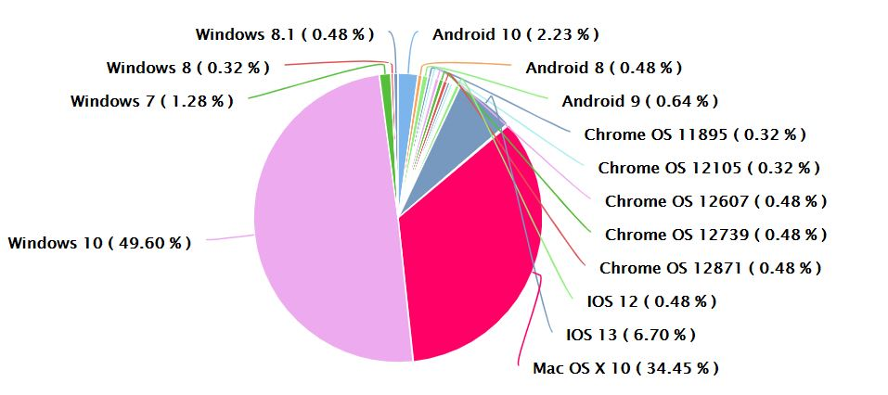

Browser Statistics - ID  
This monitor displays the browsers (and percent of use) used by Moodle users.