**Moodle Reports**

There are reports located within the Moodle platform that can make your process more efficient and allow you to view data from you Moodle course.

**Activity Completion Report**

*To access this report, click on the **Course Management icon** (*red icon at the top of your Moodle page)*, and then choose **Activity Completion** (*under the User Links column*).

The Activity Completion report shows what students have completed which activities. The manner in which this report keeps track of information is set within each activity’s settings.

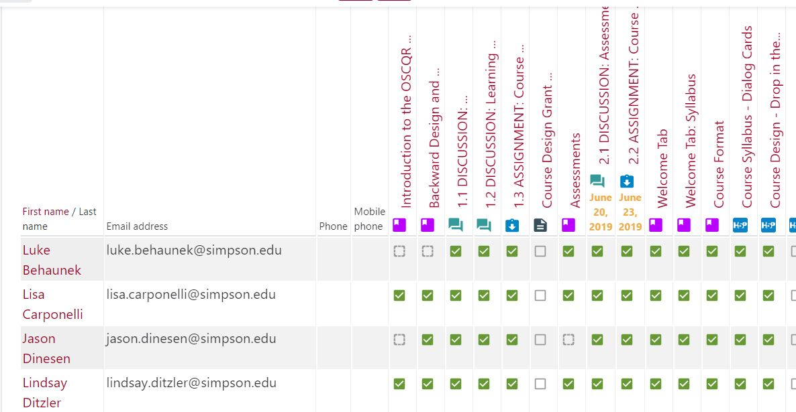

When setting up activities within Moodle, there are three options for activity completion:

* ***Do not indicate activity completion*** - this will not show checks (ticks) next to

**Course Activity Overview Report**

* *To access this report, click on the **Course Management icon** (*red icon at the top of your Moodle page)*, and then choose **View** **Activity Report** (*under the User Links column*).
* The Activity Report report shows the number of views and the last access date and time for each activity and resource in the course.  
  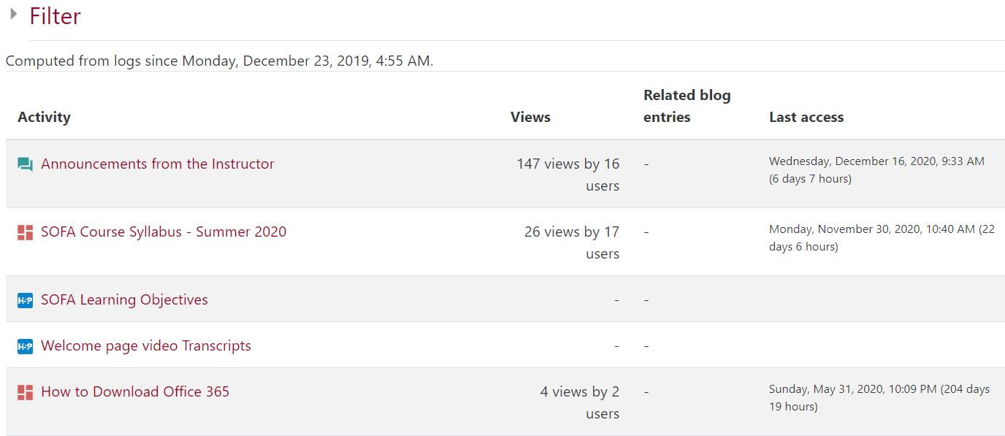
* For more information about the Activity Report report, please go to [**https://docs.moodle.org/39/en/Activity_report**](https://docs.moodle.org/39/en/Activity_report).

**Course Completion Report**

* *To access this report, click on the **Course Management icon** (*red icon at the top of your Moodle page)*, and then choose **Course Completion** (*under the User Links column*).
* The Course Completion report shows if a course has been completed. It can show the progress a student is making towards finishing the course according to specific criteria. The criteria can include meeting an activity's grade level or a manual checking "complete" by either the student and/or teacher.  *Course completion settings are set at the course level.
* For more information about the Course Completion report, please go to [**https://docs.moodle.org/39/en/Course_completion**](https://docs.moodle.org/39/en/Course_completion).

**Course participation**

* *To access this report, click on the **Course Management icon** (*red icon at the top of your Moodle page)*, and then choose **View** **Course Participation Report** (*under the User Links column*).
* The Course Participation Report report generates a list of who has participated in a given activity and how many times they have participated This report can be filtered by role, group, and action (View or Post), allow individuals or groups students (e.g. those who have not participated) to be easily messaged.
* *Use this report to email students who haven’t completed an assignment.  
  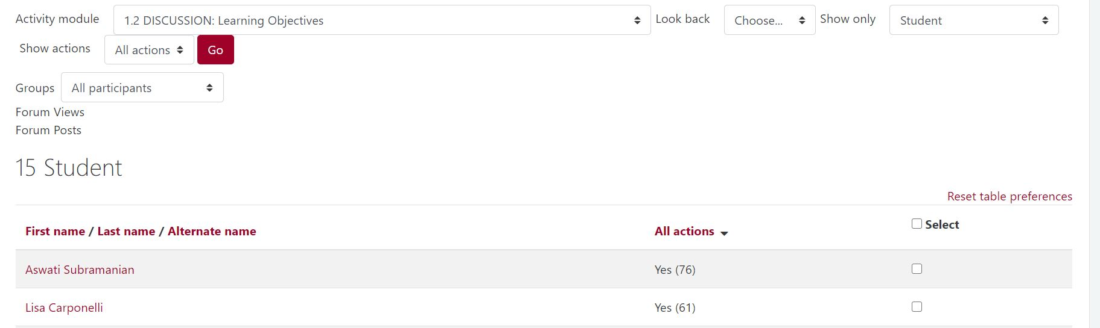
* For more information about the Course Participation Report report, please go to [**https://docs.moodle.org/39/en/Participation_report**](https://docs.moodle.org/39/en/Participation_report).

**Edit Dates**

*To access this report, click on the **Course Management icon** (*red icon at the top of your Moodle page)*, and then choose the **Course Administration** (*under the Course Settings column*). Choose **Reports** from the tabs at the top, and then choose **Dates**.

The Edit Dates Report lets you edit all the dates for all activities in your course on a single page.  
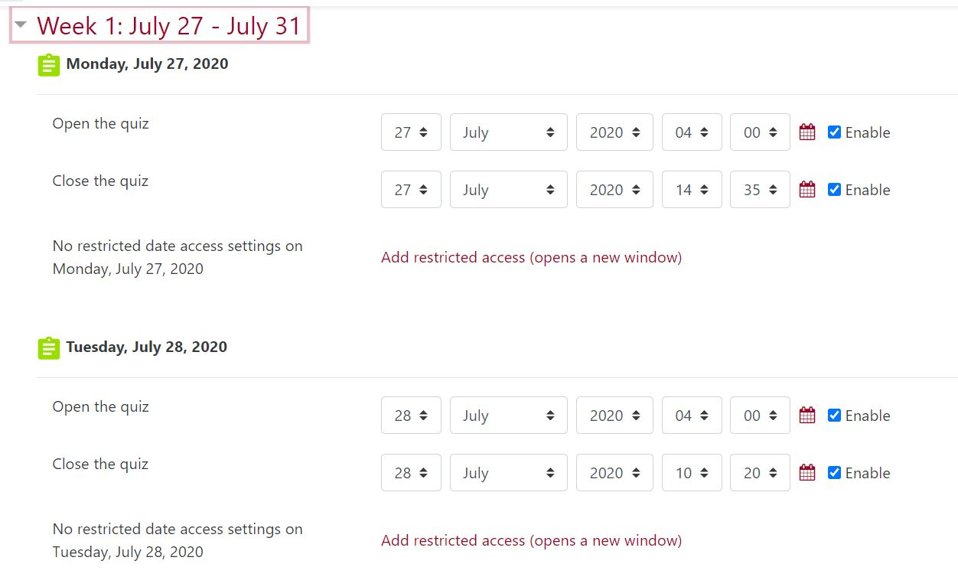

For more information about the Edit Dates Report report, please go to [**https://docs.moodle.org/39/en/Edit_dates_report**](https://docs.moodle.org/39/en/Edit_dates_report)

**Export Rubric Grades Report**

*To access this report, click on the assignment, and then navigate to the red cogwheel located in the upper right-hand corner of the assignment. Choose **Export Rubric Grades**.   
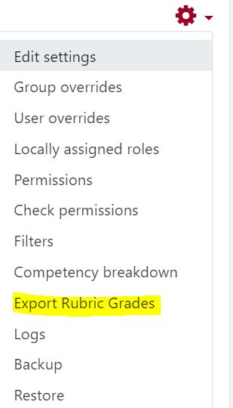

The Export Rubric Grades Report exports the component grades from a Rubric or Marking Guide for an assignment.   
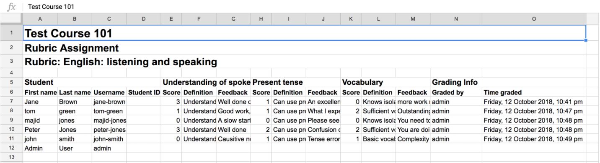

For more information about the Export Rubric Grades Report report, please go to [**https://moodle.org/plugins/report_componentgrades**](https://moodle.org/plugins/report_componentgrades).

**Forum Summary Report**

*To access this report, click on the forum, and then navigate to the red cogwheel located in the upper right-hand corner of the forum. Choose **Forum Summary Report.  
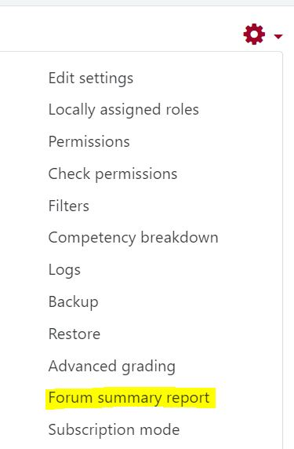**  
The Forum Summary Report will appear on the Moodle page showing each student and their participation in that specific forum.  
 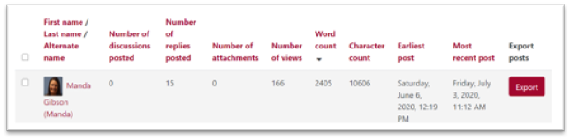  
For more information about Moodle Forums and the Forum Summary Report report, please go to [**https://docs.moodle.org/310/en/Using_Forum**](https://docs.moodle.org/310/en/Using_Forum).

**Logs/Live Logs**

*To access these reports, click on the **Course Management icon** (*red icon at the top of your Moodle page)*, and then choose **Logs or View live logs**(*under the User Links column*).

The Logs and View live logs reports provide data showing every click within your Moodle course shell. You can filter this report by the individual participant, days of the week, activities, actions, sources, or events. The logs will show the date and time of the click, the user's name, activity name, and the IP address.   
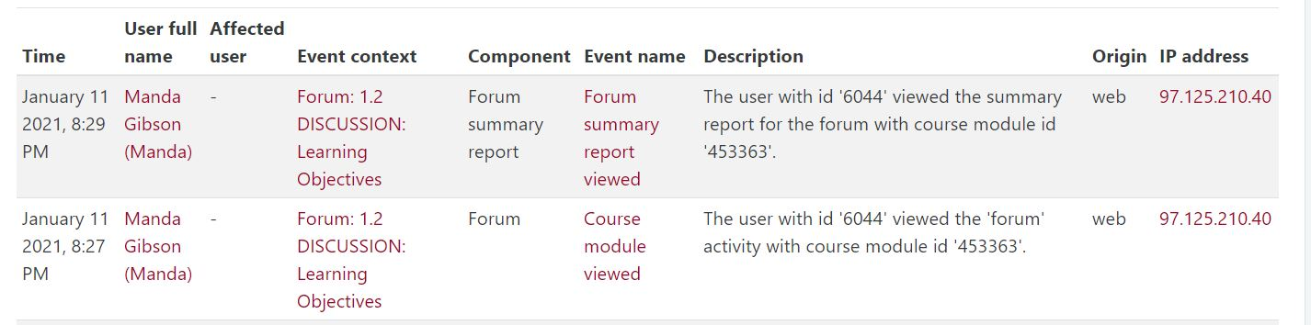

For more information about Moodle Logs, please go to [**https://docs.moodle.org/39/en/Logs**](https://docs.moodle.org/39/en/Logs).

**Printable Roster Report**

*To access this report, click on the **Course Management icon** (*red icon at the top of your Moodle page)*, and then choose **Course Administration**(*under the Course Settings column*). Choose the **Reports tab**, and then choose **Roster.**

This report allows you to print a class roster with profile images and names. You can print groups (that you have already created in your course), you can choose just one participant, you can adjust the size of the profile images, and you can create a Web or printable report too.   
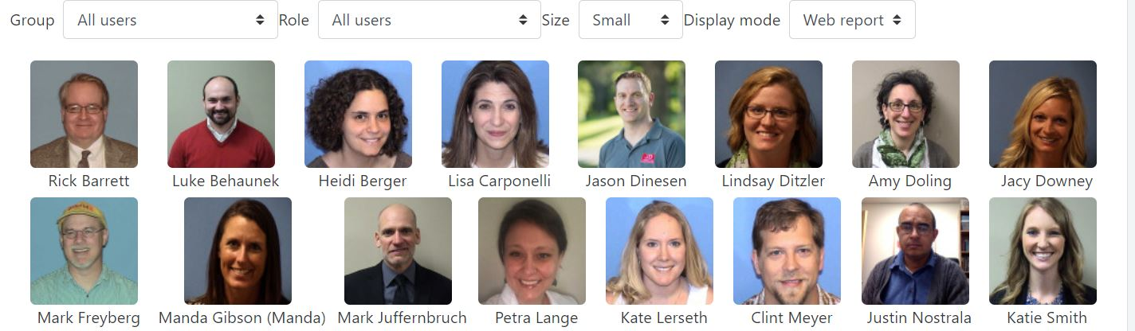

For more information about the Roster report, please go to [**https://moodle.org/plugins/report_roster**](https://moodle.org/plugins/report_roster).