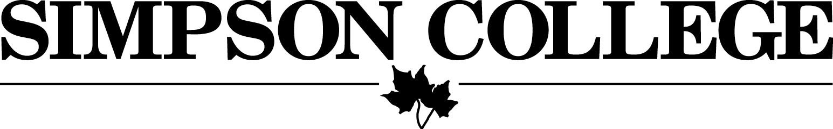

TUITION REFUNDS AND TITLE IV RETURN POLICY

Adjustments due to enrollment changes
A reduction of credit hour enrollment within the add/drop period of the semester or term may occur without tuition penalty. Tuition charges and financial aid offers will therefore reflect the student’s enrollment at the end of the add/drop period. (The add/drop period is always posted on the academic calendar). After the add/drop period has expired, a change from full-time to part-time status or a reduction in any credit hour enrollment, other than a complete withdrawal, will not change tuition charges or financial aid. For example, a student enrolled full-time will receive no tuition adjustment for dropping below full-time enrollment after the add/drop period of the traditional semester. Tuition adjustments for increased enrollment will continue throughout the term.

Title IV Return Policy and refunds due to student’s complete withdrawal from the College (R2T4)
A student interested in withdrawing from Simpson College should file a withdrawal form in the Office of Student Development or the Office of Continuing and Graduate Programs and make an appointment with the Office of Financial Aid in order to fully understand the financial implications of doing so. However, a student may also call or email the Office of Student Development or the Office of Continuing and Graduate Programs to begin the process.
Simpson College engages faculty and staff members in advance for a full academic year. Many other expenses for maintaining the college are likewise commitments of one or more years into the future. Therefore, a student who withdraws does not reduce materially the costs of operating the college. A student who withdraws before the 60% point in time in the semester or summer session will receive a refund of applicable tuition, room, food (meal plan) and fees. The amount of the refund is based on the percentage of the semester that has not been completed. Financial aid will be returned to federal, state and Simpson programs based on the same percentage. Title IV aid that is unearned is required to be returned and credited in the following order: Federal Direct Unsubsidized Loans, Federal Direct Subsidized Loans, Federal Direct PLUS (parent or graduate), Federal Pell Grant, Iraq and Afghanistan Service Grant (IASG), Federal SEOG, TEACH Grant, and other Title IV aid. If a student has a disbursed private loan at the time of their withdrawal, the school will keep enough of the private loan to make sure the student’s account is in good standing and will return any funds not needed back to the private loan program. Simply stated, a student who withdraws after completing 20% of the semester will be charged 20% of the applicable tuition, room, board (meal plan) and fees and would retain 20% of their financial aid. If funds have been released to the student because of a credit balance on the student’s account, then the student may be required to repay some of the federal grant and loan funds that were released to the student. Title IV funds may not cover all unpaid institutional charges due to the institution upon withdrawal from the college.

After the 60% point in the semester, no refund is due, nor will financial aid be returned to any programs. The portion of the semester completed is based on calendar days from the first day of the semester through the last scheduled day of finals, including weekends and breaks that are fewer than five days in length. One exception to the 60% rule, is for students who are enrolled in modular programs (Term 1, Term 2, Term 3, or Term 4). A student enrolled in these programs who successfully completes one module with a passing grade, will be exempt from the R2T4 calculation if the module that was successfully completed included 49% or more of the number of days in the entire term.

Students who do not go through the “official” withdrawal process (i.e. leave campus without filing withdrawal papers or notifying the College) will be deemed to have attended through the mid-point in the semester unless the last date of attendance can be documented. They will have their charges and financial aid adjusted accordingly. This policy is subject to federal regulations, specifically the Higher Education Amendments of 1998, Public Law 105-244.

Example of a recalculation for complete withdrawal from Simpson College
The enrollment period for the semester in this example contains 104 days. Earned percentage examples are below:
- Withdrawal on day 2 = 2/104 = 1.9%
- Withdrawal on day 8 = 8/104 = 7.7%
- Withdrawal on day 63 = 63/104 = 60.5% - NO REFUND or RETURN OF TITLE IV FUNDS REQUIRED

This example is for illustration purposes only. Actual charges and refund amounts may vary. The following is an example of charges and credits for a student who completely withdrew from Simpson College and all classes on the 46th day of the semester (46/104 = 44.2%).

Original charges |  | Revised charges
$23,828 | Tuition and fees | $10,532
$5,250 | Living Expenses: housing and food plan | $2,321
Original financial aid |  | Revised financial aid
$2,723 | Federal Direct Student Loan | $577 (retained amount)
$17,500 | Honor Scholarship | $7,735 (retained amount)
$3,750 | Iowa Tuition Grant | $1,657 (retained amount)
$1,123 | Federal Pell Grant | $1,123 (retained amount)
Total original aid |  | Total revised aid
$25,096 |  | $11,092
Student payment |  | Revised student payment
$3,982 |  | $1,761

