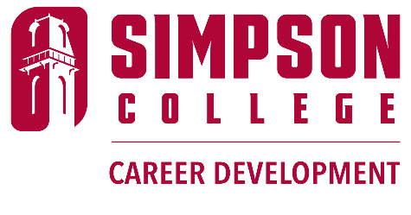
Simpson College graduates are nothing short of extraordinary. The latest first-destination report reveals an impressive 100% placement rate for 16 majors- every single graduate is either employed or continuing their education. Overall, more than 94% of our graduates are thriving in their careers or furthering their studies. Discover the incredible paths our graduates are taking after they cross the stage!
2023 Destination Report Reveals Impressive Outcomes for Simpson Graduates - Simpson College
Career Development is dedicated to empowering your student for professional success through career exploration and experiential learning. We aim for every student to graduate with a sense of purpose and be competitive candidates for their pursuits after college. Click here to meet our team and explore our resources.
Internships & Career Development - Simpson College
How do we help your student unlock their professional potential? Through personalized appointments, assessments, and tailored support, Career Development is committed to helping students explore opportunities, polish their professional skills, and make valuable connections. We host large and small-scale employer events and connect with students in the classroom to ensure no one misses out. Plus, we offer two exclusive courses for academic credit: COOP 119: Career Observation and COOP 219: Internship Prep. Career Observation, held during the May term, allows students to explore their strengths, discover career options, and shadow professionals. Internship Prep equips students with everything needed to land their dream internships-perfecting resumes, enhancing networking skills, acing interviews, and optimizing LinkedIn profiles. Students at Simpson College also have the chance to earn academic credit for internships. The National Association of Colleges and Employers (NACE) reports that students who utilize career services are 2.2 times more likely to secure a paid internship—and those internships correlate to more job offers after graduation! Ready to see success for yourself? Click here to read inspiring stories from past student interns.
Internships Open Doors: Changing Game Plans - Simpson College
Career Development is here to support your student from day one on campus through graduation, ensuring they are ready to tackle full-time employment or graduate school. According to NACE, students who utilize the career center receive an average of 1.24 job offers, compared to just 1 offer for those who don’t. What’s more, each additional visit to the career center increases the average number of offers by 0.05. And the best part? Our support doesn’t stop at graduation! Simpson College Career Development continues to offer valuable resources and assistance to alums. If your student ever needs guidance, they can reach out to careers@simpson.edu, and we’ll work closely with them to help them achieve their goals!

