Self-Service for Faculty/Advising

To View Your Class Schedule
From the main menu, click the Faculty icon. You will then see the sections you are teaching along with the course times, locations, and availability (Available/Capacity/Waitlisted). The Waitlist function is not used, so it will always say 0.
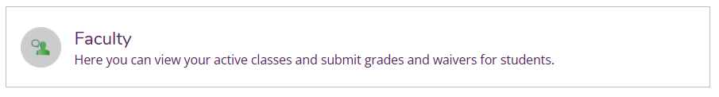
Alternative: From the menu on the left, select Daily Work -> Faculty -> Faculty Overview
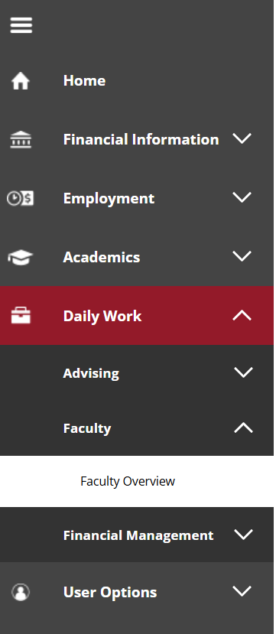

To View Class Rosters
From the main menu, click the Faculty icon
Click on the class you want to view to see the roster.
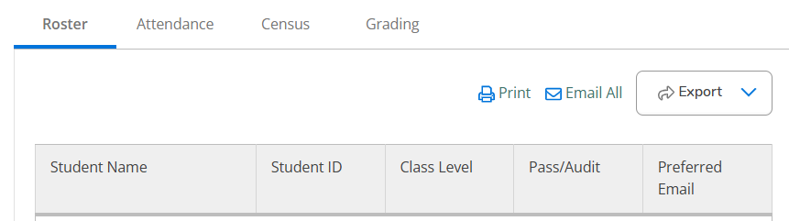
- If you click Print, something goes wrong and this is a KNOWN issue for Ellucian that they have not yet fixed. As a workaround, do not click on the "Print" option. Instead, use the native Web Browser PRINT feature to output the page if needed or export the roster and print the CSV file.
- If you click Email All, the system will open your email program and paste all the students’ names into the BCC row so that students cannot see who you sent the messages to.
- If you click Export, you can download a CSV file (i.e., a text file that can be opened in Excel). The file contains each student’s full name, their ID number, their class level (freshman, sophomore, junior, senior), and their Simpson email address.

To Submit Grades
From the main menu, click the Faculty icon
Click on the class you want to grade and then select the Grading tab.

Select either the Final Grade or Midterm 1 tab.
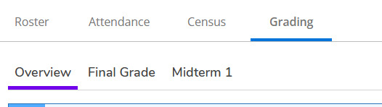

To View Advisees’ Schedules
To view one advisee’s schedule, click Advising
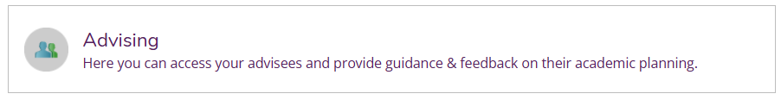
Alternatively, start from the Daily Work menu, select Advising, then select Advising Overview.
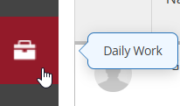
Click the View Details button for a given student.
The Course Plan shows each term individually. You can also switch from list view to calendar view.
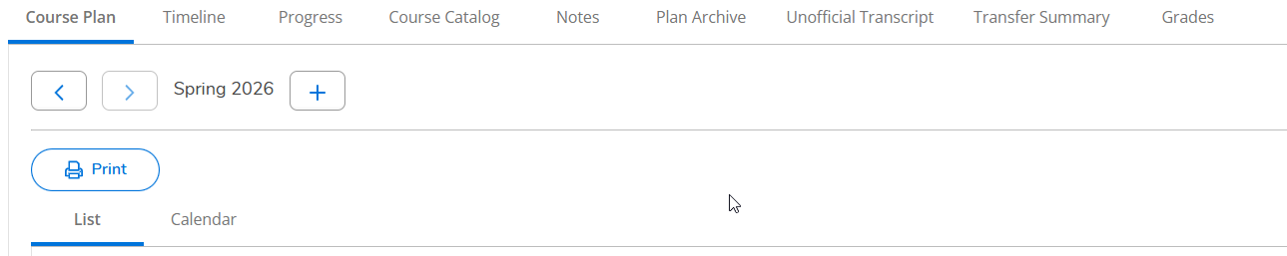

How to Mark Students as Advised in Self-Service

** NOTE – the screenshots below are generic, and our version of Self-Service is more updated, so the screenshots may not look exactly the same in our instance of Self-Service.
Advisor Workflow:
- Go to Self-Service, and select “Advising”
- To mark a student as advised, select the student, and then “View Details.” On the Advisee Details page, select “Advisement Complete”.
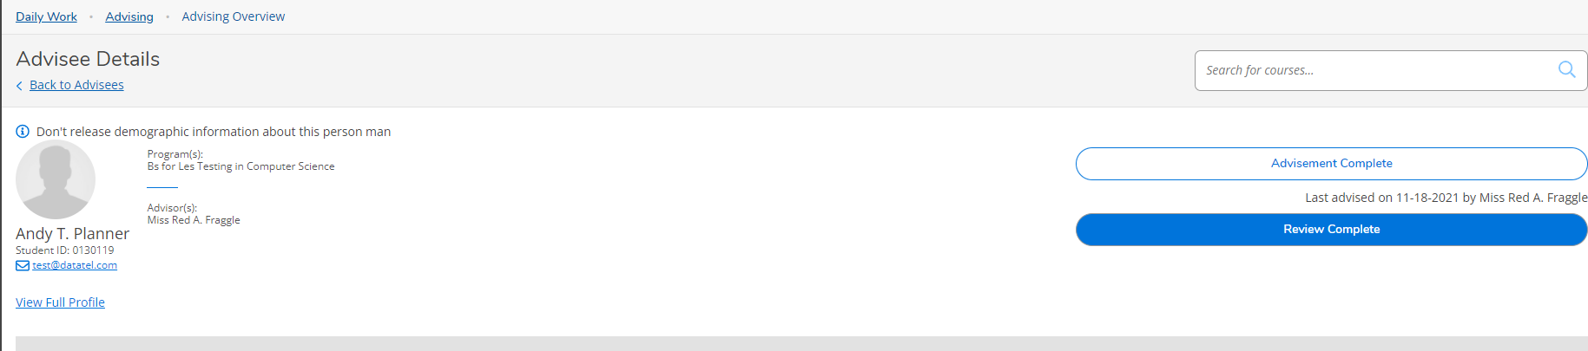

- You can view when a student was last advised as you see below.
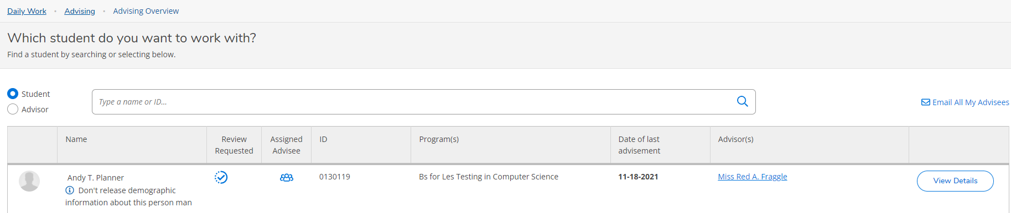

Rules for Registration:
- A student may register for Fall when they have an ADVISEMENT COMPLETE DATE after 3/1/ccyy where ccyy equals the year for Fall term. They also can add/drop class for the T4, May and summer courses if advised after 3/1/ccyy.
  - Advised Date > 3/1/2026 … allow registration for 2026/T4 and MA, summer, and 2026 Fall courses

- A student may register for Spring when they have an ADVISEMENT COMPLETE DATE after 10/1/ccyy where ccyy equals the year prior to the Spring term. They also can add/drop class for the T2 and summer courses if advised after 10/1/ccyy.
  - Advised Date > 10/1/2025 … allow registration for 2025/T2, 2026 spring and summer courses
Student view
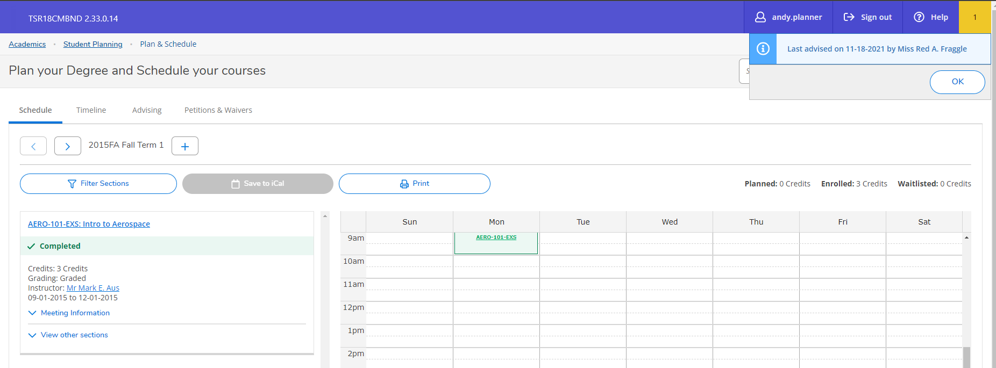
NOTES:
      - A notification about the advisement complete date is displayed when students access the Plan & Schedule page in Self-Service.
        - This message is displayed in the Notifications area in the upper right corner of the page for 10 seconds.
      - The student must navigate away from Plan & Schedule and then back to it to view the message again.
      - The message also displays with an "OK" button. If the student clicks the "OK" button, the message disappears and does not display until an advisor has clicked "Advisement Complete" again.
      - The message is only displayed on the Plan & Schedule page as described above. It does not display on the home page in the Notifications area.

How students and advisors will see their registration times in Self-Service:
Students and advisors are seeing the following registration start date messages in Self-Service Student Planning. NOTE – once their registration time has arrived, the message goes away and students will see the “Register Now” button.
- Path for students: Academics > Student Planning > Plan & Schedule – Schedule Tab > go to the future term
- Path for advisors: Daily Work > Advising > Advising Overview – click on View Details for an advisee > Advisee Details – Course Plan tab > go to the future term

Students:
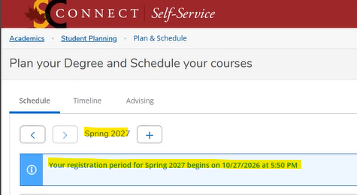

Advisors:
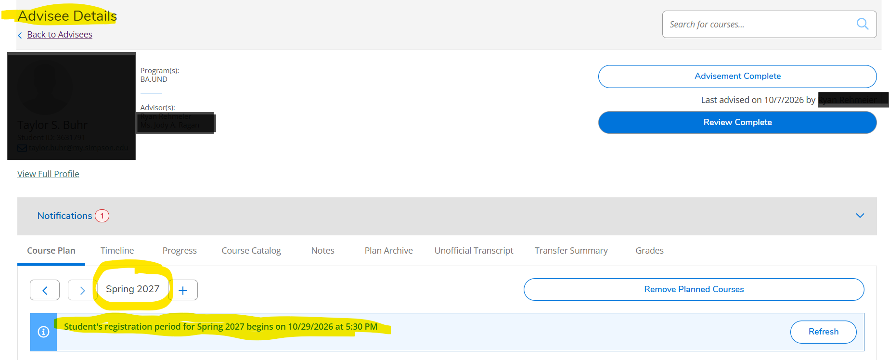
Student holds can be seen by clicking on Notifications (in the grey bar).

