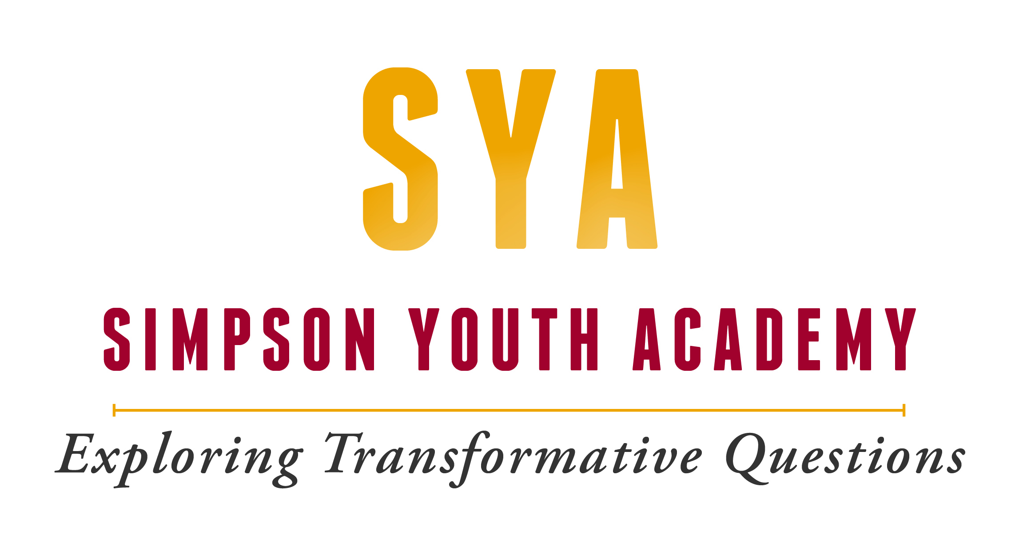

Hello!

A young person in your community is applying to participate in the Simpson Youth Academy in Des Moines, IA, which begins with a summer program June 22 – 30, 2019. The Simpson Youth Academy is a nine-month program with three components: (1) a week-long intensive, residential program of Christian education on the campus of Simpson College, (2) ongoing educational retreats and mentoring from a local leader, and (3) a youth-led project that reflects the youth’s own gifts and passions.

The Simpson Youth Academy is grounded on the conviction that high school students have gifts and power that are essential for the healing of their communities, not just in the distant future, but NOW. We are grounded within the Christian tradition and utilize resources from the United Methodist Church. And we are an ecumenical community of adult mentors and high school youth who are asking deep, faith-based questions and taking action together, in order to help youth live more fully into their vocations as agents of peace and justice in the church and the world.

Our goal is that students who participate in our program not only develop important leadership skills they can bring back to their home communities, but also discover a passion for sharing what they have experienced and learned with others. Students are most successful in continuing to develop these skills and passions when they come back to adults and peers in their life that support them as leaders with unique gifts to contribute to the community. Our hope is that youth who participate in the Academy will go on to be difference-makers within the Church, whether as professional ministers or lay-people. We want to work together with your congregation to develop youth into strong leaders for the Church of the future.

I am writing to urge you to support this young person in visible and active ways, both before and after the summer experience. This can be done through ongoing prayer or supportive messages sent to the student during the program, and through opening up possibilities for the student to present what he/she has learned when he/she returns. Support for the student by helping to raise money to cover his/her fees is also critically important, no matter the amount. Simpson College pays about $4,000 per student to run this program for the year, and then asks the student and church to pay the remaining $450 for room, board, and food. If you are able to help in any way, you and your community can demonstrate in a very concrete way your commitment to this young person as a leader, now and in the future.

I invite you to learn more about Simpson Youth Academy at our website:

simpson.edu/campus-life/campus-ministry/simpson-youth-academy

Please contact me if you have any questions or concerns. I look forward to working together with you for the support and growth of this young person!

Blessings,

Eric Rucker, M Div
Director, Simpson Youth Academy
eric.rucker@simpson.edu
515-961-1406

