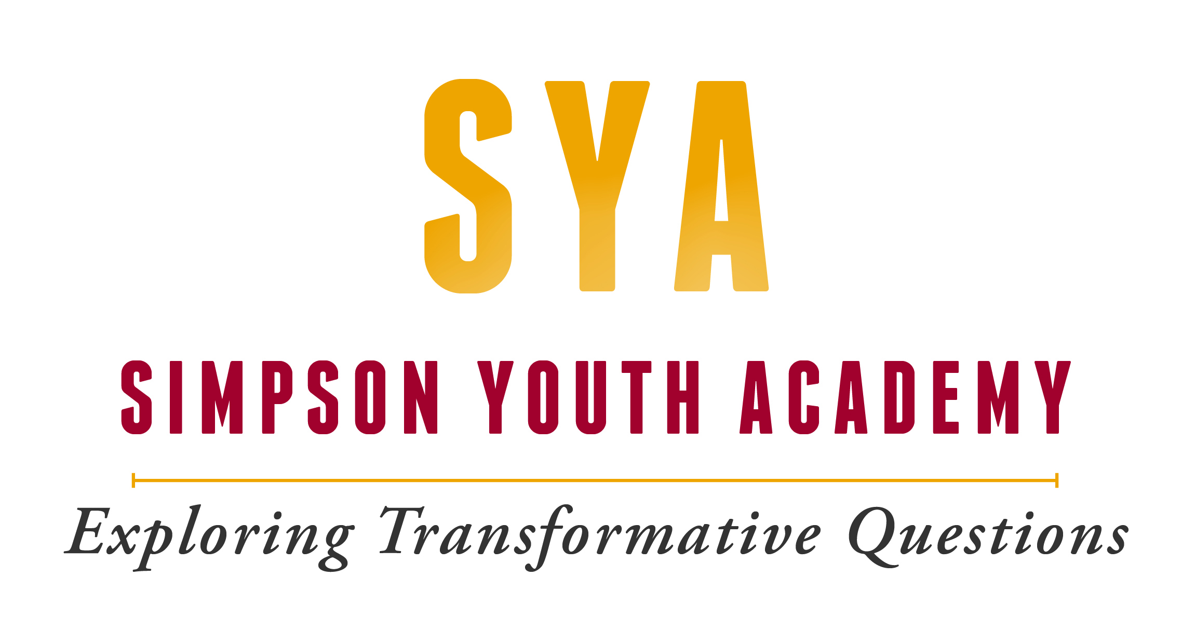

An Ecumenical Exploration of Faith, Service, & Calling for 2020-2021 High School Sophomores, Juniors, & Seniors

Funded by the Lilly Endowment

and

October 2020

Dear High School Sophomore, Junior, or Senior,

Attached you will find an application for the Simpson Youth Academy 2020-2021, of which the residential portion runs June 19 – June 27, 2021. We are delighted by your interest in the program!

At SYA, we believe that young people need theology – the study of God and God’s relationship to the world – as one of their resources to draw upon as they explore their relationship to the world. And we believe that the world needs young people to contribute their perspectives and their energy in order to promote social justice and the common good. We gather twenty-five rising high school juniors and seniors from throughout the region for our summer Residency, a nine day and eight night experience in Christian education. Our goal is to help you explore questions of faith in a supportive, mentoring community where your views, talents, and insights are welcomed and encouraged.

So, what will this look like? Kind of chaotic, actually, as we live out our commitment to practicing our faith in the concrete situations of everyday life. We’ll make it possible for you to engage in academic exploration, service-learning, and community building with a diverse group of “scholars” (as we call the participants) and staff. You will take an Exploratory Course that focuses on the history of Christianity and different ways to read the Bible. You’ll engage in Service Immersion trips in organizations in the city of Des Moines, which might include work with people who are homeless, communities involved in the resettlement of people who are refugees or immigrants, farming and creation care, and interfaith dialogue. We do our best to bring together youth from diverse backgrounds, so that you will be challenged to learn how to engage honestly and respectfully with people whose experiences, commitments, and perspectives are different from yours. You’ll have an opportunity to plan and lead worship on Simpson’s campus, and to worship with other faith communities around Des Moines. And there will be time for relaxation and play, like choir and music, drama group, art, basketball, or ultimate Frisbee. Because the Residency is so busy, and because we emphasize building a community as an important part of our work together, we require that all Academy participants be present for the entire Residency, arriving June 19 and departing June 27, 2021. It is not possible for you to participate in other programs (camps, mission trips, etc.) during the nine-day Residency.

The Residency will launch you and your cohort of peers into a nine-month process of learning, action, and reflection. Your post-Residency experience will be composed of ongoing time with a local mentor in your home community and two weekend retreats with your cohort (scheduled for October 2021 and February 2022, specific dates to be determined by your cohort). Lastly, you will design a small final project based on your own passions and implement it in the spring 2022. If you are accepted into the Academy, we will work with you to identify a mentor and a project after you have completed the summer Residency. The mentor will be an adult from your own community whom you respect and with whom you will meet 3 times between September 2021 – April 2022. If you are accepted into the Academy, you will be asked to do your best to participate in all portions of the Academy year: the Residency in June 2021, the mentor relationship and retreats, and the final project in the spring of 2022. Completion of SYA will automatically qualify you for a $1,000 scholarship to attend Simpson College, or provide a strong testament to your maturity and accomplishments when applying to other colleges.

We know that the Residency commitment might hinder other options for summer study or employment. We believe so strongly in SYA that we make the program available to you at a fee far below what the program actually costs. To run the Academy costs about $4,150 per student per year, but through generous donations from the Lilly Endowment and Simpson College, we provide every participant with a $3,650 scholarship! This means that you will only be asked to pay $500. Scholarships are available. Please do not let the cost of SYA deter you from applying. We will work with you, your family, and your home congregation to make it possible for you to attend.

COVID-19 Questions:

We are unsure of what the public health situation with COVID-19 will be in the spring and summer of 2021. But we do promise that we will offer a quality program for your growth during that planned time period of June 19-27, whatever the format may be. We are planning and hoping that we can gather in person. But if guidance from public health experts (CDC) tell us it is still not safe, we will pivot to a hybrid or virtual model if needed. We are committed to proceeding with SYA in some form!

How to apply:

1.) Complete the below application (which includes personal/demographic info, and 4 essay questions), and email it to director Eric Rucker at eric.rucker@simpson.edu.

2.) Identify two adults who are not family members to complete recommendation forms for you. One should be a teacher from your school, the other a pastor, coach, or other mentor in your life. Email these two people the Recommendation Form, and after they complete and sign it, have them email it directly to director Eric Rucker at eric.rucker@simpson.edu. The recommenders should not send their completed forms back to you.

The priority deadline by which we would like to receive all your materials is February 1, 2021.

Applicants who meet this deadline will be given first consideration for acceptance into the program as well as for financial aid. However, if all spots are not already filled after the priority deadline, the second and final deadline for applications will be March 1, 2021. Keep in mind that applicants who wait until March 1 may not be considered if all Academy spots are already filled. Please note that it is your responsibility to make sure that all your application materials arrive on time, so you may want to give your recommenders a friendly reminder several weeks before you need them to complete the form. We run a rolling acceptance process, so if you submit your materials in the weeks or months before February 1, there is a possibility that you might hear about your acceptance status early.

Acceptance and Registration:

Our admissions staff will notify you of your admission status by March 1, 2021.

If admitted, you will have until April 18, 2021 to confirm your commitment to the Academy in writing, and to send the $100 admissions deposit (which will serve as a non-refundable security deposit for the Academy). Your full payment of the additional $400 will be due by May 15, 2021.

Please note that our students often work with their churches to help cover the remaining tuition fee. For more information about financial aid, see the pages below.

If you have any questions about the Simpson Youth Academy or application process, please contact us by phone (515.961.1406) or email (eric.rucker@simpson.edu).

Blessings,

Eric Rucker, M Div
Director, Simpson Youth Academy

2020-2021 Academy Application; please type responses

Name_____________________________________________________________________
last first middle preferred

Street Address _________________________________________________________________

City_______________________ State___________________ Zip code____________________

Student Phone:_______________ Student Email: ______________________ Gender: _______

Parent/Guardian Email: ________________________Parent/Guardian Phone: _____________

Date of birth _____________ Place of birth __________________________________________
city state (country, if not U.S)

Religious Affiliation ____________________________________________________________
Church/local religious community denomination

Mailing Address of religious community_____________________________________________

OPTIONAL From what part(s) of the world do you trace your predominant ethnic heritage?

____Africa ____Asia ____Caribbean Islands ___Central or South America

___Europe ___Middle East ___North America (American Indian or Alaskan Native)

____Pacific Islands ____Other (please specify)________________________________

OPTIONAL We have received funds for 2021 to offer additional scholarships to LGBTQIA youth. Check here if you would like to apply for one of these scholarships: _______

School name____________________________ Anticipated graduation date:________________

Address_________________________________________________________________

City_______________________ State___________________ Zip code_____________

School phone (___)____________Name of school guidance counselor_______________

Hobbies or special interests_______________________________________________________
_____________________________________________________________________________
How did you hear about the Simpson Youth Academy? (brochure, my minister, teacher, etc.)__________________________________________________________________________

Are there other youth you know who might be interested in the Simpson Youth Academy and should be added to our mailing list in the future? If so, please tell us their name, contact information, and CURRENT grade in school.
______________________________________________________________________________
______________________________________________________________________________
______________________________________________________________________________

RECCOMENDATIONS: Two letters of recommendation are required as part of your application. Choose adults who know you well and who are NOT members of your family. At least one of your recommenders must be a high school teacher with whom you have successfully completed a class and who can comment on your academic abilities or interests. The other should be a mentor who knows you well (another teacher, pastor, youth pastor, coach, etc.) Please list below the names, phone numbers, and addresses of the persons who will complete the recommendation forms.

Name:____________________________________________________ Phone:______________

Email: __________________________________________

Address:______________________________________________________________________
street address city state zip code

Name:____________________________________________________ Phone:______________

Email: ___________________________________________

Address:______________________________________________________________________
street address city state zip code

ESSAYS: The SYA admissions committee are interested in learning more about you. References tell us many things about your academic and personal achievement, but they tell us little about the questions that intrigue you or how you think about them. Therefore we would like for you to write a brief essay in response to each of the first three questions, and then one of the two questions listed under number 4. There are no “right” or “wrong” answers; please just try to answer the questions honestly and thoughtfully.

Each response should be 250-300 words (at least half a page, single-spaced). Please type your responses, and be sure to put your name on each page.

1. What have you done in the last year that you really care about, and why is it important to you?

2. What interests you most about the Youth Academy, and why do you want to attend? What kinds of questions about God, God’s involvement in the world, faith, or your calling would you like to explore at the Simpson Youth Academy?

3. Describe a time when you went “outside your comfort zone.” (like visiting a strange or foreign place, trying something new, encountering a person or people different than you, reading a book that challenged your thinking, etc.) How did you respond at the time? What do you feel or think about it now?

4. CHOOSE ONE:

A. What do you consider to be important about yourself that others might miss? (like convictions, qualities, feelings, spiritual or religious feelings, etc.)

B. How have your experiences or thoughts about God shaped your commitments and your understanding of the world?

I certify that all of the above information is correct to the best of my knowledge, and that the enclosed essays are my work alone. In order to participate in the Simpson Youth Academy starting in the summer of 2021, I understand that I must complete my current year of high school and plan to enter the next class in the fall of 2022. If I am accepted as an SYA scholar and choose to attend, I agree to participate in the full duration of the Residency, mentoring, and project in 2021-2022, and I will abide by the rules and regulations of the Simpson Youth Academy.

E-Signature of applicant______________________________________ Date:______________

I certify that I give permission for my son/daughter to apply for the 2021 Simpson Youth Academy.

E-Signature of parent/guardian _______________________________Date:______________

The priority application deadline is February 1, 2021.

Application Checklist:
_______Completed application form with applicant & parent/guardian signature

_______4 essays

_______2 recommendations emailed from adults to SYA director

Financial Aid

The Simpson Youth Academy works hard to make the program affordable for all youth. The nine-month Academy costs about $4,150 per student to run. But thanks to the generosity of the Lilly Endowment and Simpson College, we provide every student with a scholarship of $3,650! Therefore, students are asked to pay only $500 tuition, which will cover housing and meals for the summer Residency and retreats.

If you are unable to pay the $500, we ask that you please first consider asking your church or community for financial support. We are happy to help you in this process of raising the remaining tuition. To get started, contact our program director for a copy of the SUPPORT LETTER. You can give the letter to your pastor, youth pastor, or board members/elders in your religious community to help explain the program and the funds that you are raising. Please contact us if you need help in this process or would like to figure out other ways to raise support! Do so by emailing program director Eric Rucker at eric.rucker@simpson.edu or calling 515-961-1406.

If you are unable to raise financial support from your community, you may apply for additional financial aid from the Academy. Application for financial aid and application for the program itself occur on the same timeline. If you wish to request financial aid, please contact our program director for the FINANCIAL AID REQUEST FORM. Additional scholarships are rewarded on a rolling basis and are first come, first serve, so the earlier you apply, the more financial aid will be available. Applicants who submit their application materials and Financial Aid Requests before or by the priority deadline of February 1 will receive priority for financial aid. You will be notified about your admission status before or by March 1, 2021. Likewise, if you have completed the Financial Aid Request Form by the priority deadline, our staff will let you know by March 1 whether you have received additional financial aid, and will work together with you to cover any remaining costs for your admission. Again, please first ask your community for financial support before applying for additional aid from the Academy.

The Simpson Youth Academy does not use financial information to determine admission to the program. Likewise, we encourage students not to let financial concerns deter them from applying.

Financial Aid Timeline:

February 1, 2021: Priority deadline for application forms and Financial Aid Requests

March 1, 2021: Applicants notified about admissions status and additional financial aid by this date

April 18, 2021: Applicants commit to Academy in writing and submit $100 non-refundable security deposit**

May 15, 2021: The remainder of tuition – $400 – is due.

**Students will know by this time how much of the remaining tuition will be covered by financial aid

MISSION STATEMENT

The Simpson Youth Academy is a center for youth faith education funded by the Lilly Endowment and Simpson College in Indianola, Iowa. We at the Simpson Youth Academy believe that young people have power and gifts that are essential for the healing of the world, not just in the distant future, but NOW. Grounded in the Christian tradition and utilizing resources from the United Methodist Church, we are an ecumenical community of young people and adult mentors who explore deep faith-related questions and take action, in order to equip youth to live into their callings as agents of peace and justice in the church and world. We do this through:

- The Summer Residency: In June, we gather a diverse group of 25 rising high school juniors and seniors for a rigorous nine-day residential experience of worship, service, and reflection on Simpson’s campus.

- Ongoing Mentoring: In the nine months following the Residency, participants continue their learning through 2-3 meeting with an adult mentor within their local community, as well as 2 ongoing retreats with their cohort of peers.

- Final project: In order to embody the values and convictions developed during the Academy, participants work to plan and implement a small project that reflects their own concerns.

For more information about the Simpson Youth Academy, please contact us:

Eric Rucker, M Div.
Director, Simpson Youth Academy
eric.rucker@simpson.edu
515-961-1406

