Camtasia Relay 4 Instructions
November 6, 2012 Updated
Go to https://fog.simpson.edu/relay and enter your username and password.
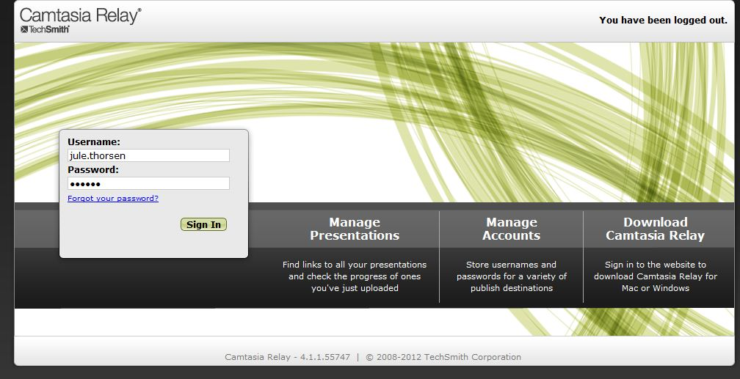

To download your recorder, click on download Camtasia Relay and select the device that you are using.
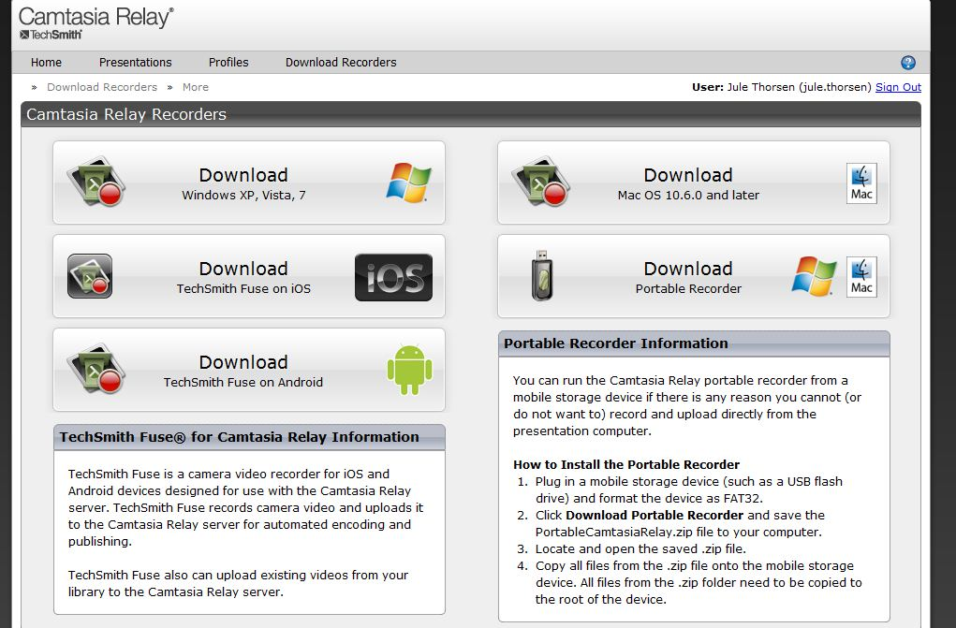
When you click on the appropriate version of the software, if you are on a Windows computer running Windows 7, you will see a dialog box similar to the image below.
If you are running Windows XP, there will be a dialog box that looks different, but will still have the same options in it. Click Run to run the installer. In the installer, accept the default options to install the software.
When the installer has completed on Windows, it will open the recorder and you will see a window similar to the one below.
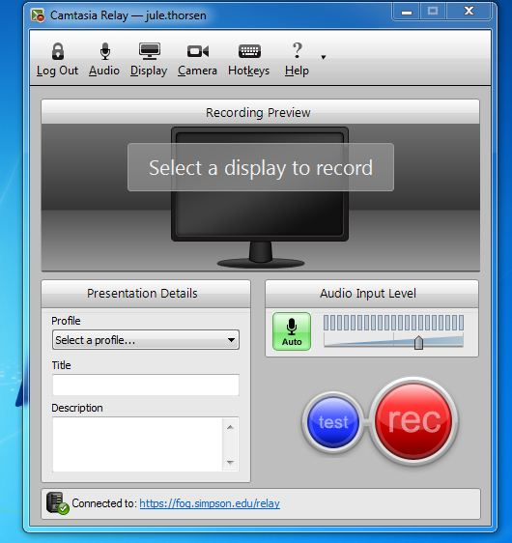
A profile will be available to you so that you can select it. Please title your presentation and enter any additional description that you may need later. You may then select from the additional settings across the top of the screen.
If you do not want to make a recording using the software at this time you can close this window.
If you have problems or questions when installing the recorder, please call Information Services at 515-961-1681.
When the installation is complete, you will have an icon on your desktop icon in Windows that looks like this:
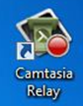
To use Camtasia, double click on the desktop icon and open the software and you will see the screen where you can choose the profile and start the recording as shown here:
One of the new features in Camtasia 4 allows you to add a recording of the presenter in the bottom right hand corner of the screen. That allows the student to see the faculty member’s face as they are speaking AS WELL as the image that is on the presenter’s computer screen.
To use this feature, be sure to click on camera icon above the recording preview area of this dialog box.
Once the recording has been made return to https://fog.simpson.edu/relay The address is also located at the bottom of the Camtasia screen shown above, you can also click on the URL in the dialog box.
Then open your presentations screen by clicking on the Presentations link at the top of the Camtasia Relay webpage.
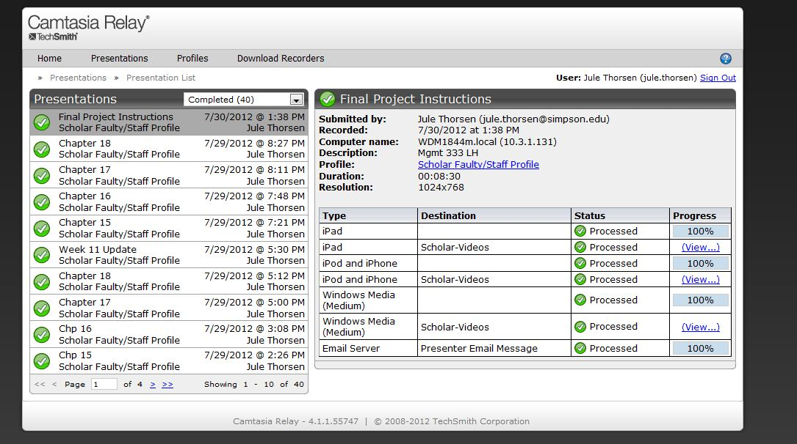
There you can follow along as Camtasia processes your video. Do not close your laptop lid or turn off your computer if it is not done downloading. Once the video is successfully processed then you can click on the word (View…) and you can download your video to your computer.
To do this be sure to “right click” on the word “View” and choose to “save as” the file to a place on your computer where you can find it again if you get the choice or it will automatically save to the place where downloads go on your computer.
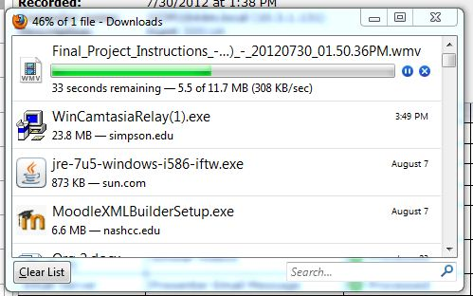
Depending on your computer, if you are using a Windows machine, the file will download into your Downloads folder and you will need to move it from there to store it where ever you chose on your machine.

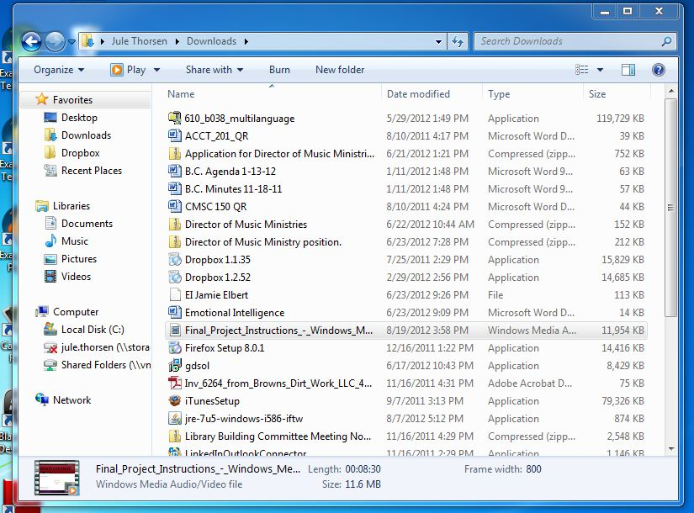
The file is now available for you to locate the file wherever you wish to store it permanently.
To upload the file into Scholar use to “Add a Resource” and then choose to add a “File.” Be sure to remember to select the correct setting for the display option. See the screen shot below for the place to make that display setting. It is preset to “Automatic” and you need to manually make that change.

