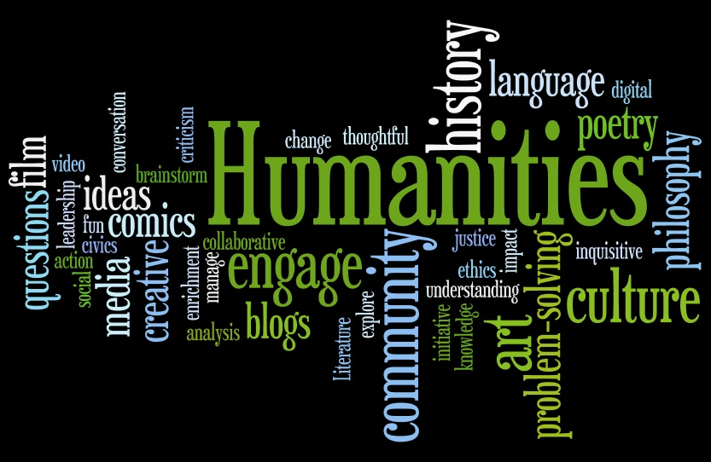

Image from the National Endowment for the Humanities (www.neh.gov)

Call For Papers

MUCH: Midwest Undergraduate Conference in the Humanities, 2015

Saturday, November 7, 2015 Wartburg College _________________________________________________________________________________________________
Wartburg College in Waverly, Iowa will host the 5th Midwest Undergraduate Conference in the Humanities on November 7, 2015. We invite submissions focusing on any area of original research-based scholarship in the humanities, including creative work, from colleges and universities in the Midwest. Presentations may take the form of 10-15 minute papers, readings, displays, and lecture-recitals. We particularly welcome scholarship utilizing interdisciplinary approaches and/or engaging with questions of diversity.

Students will need to ask a faculty member in their field of research to sponsor the paper. The faculty member should be willing to offer guidance as the student develops and refines the project. We would also like to extend an invitation to faculty sponsors to attend the conference and to serve as panel moderators.

Proposals (200 word max) should be submitted along with the submission form to: MUCHconference@gmail.com. This address should be used only for submissions.

Questions can be submitted to Zak Montgomery (zak.montgomery@wartburg.edu)

Deadline for submissions: October 2, 2015 Anticipated Registration Fee: $25

Submission Form
MUCH: Midwest Undergraduate Conference
in the Humanities
November 7, 2015

Student Name:

Title of submission:

School:

Student Email:

Student Phone:

Faculty Sponsor Name/Discipline:
(Sponsors are encouraged to attend the conference)

Faculty Sponsor Email:

Faculty Sponsor Phone:

Faculty Sponsor planning to attend: Y/N

Faculty Sponsor willing to serve as a moderator: Y/N

________________________________________________________________
Student Signature

_________________________________________________________________
Faculty Sponsor Signature

Brief Abstract (200 words maximum, please attach on a separate page) If you will not be presenting a research paper, please indicate in your abstract the preferred presentation format for your submission (e.g., lecture recital, poster).

Please submit this form and your abstract as a .doc, .docx, .pdf, or .rtf file to MUCHconference@gmail.com by October 2, 2015.

Anticipated Registration Fee: $25 (helps to cover food, communications, facilities, and programming for the conference). The fee will be payable by check made out to Wartburg College by October 25, 2015. Please indicate who the check is covering and send to:
Midwest Undergraduate Conference in the Humanities, c/o Zak Montgomery
English & Modern Languages, Wartburg College, 100 Wartburg Blvd, Waverly, IA 50677

MUCH Guidelines for Students

1. Please make certain to submit the entire application including the abstract. Electronic signatures are acceptable. Please submit materials as a .doc, .docx, .pdf, or .rtf file to MUCHconference@gmail.com by October 2, 2015.

2. Papers written for classes are welcome, but we expect that the presentations at the conference will be improvements on these papers. You should plan your revision in coordination with your faculty sponsor.

3. The registration fee will be $25. You may be able to acquire transportation and funds for registration fees and travel from your sponsoring department or college, and we recommend that you submit your application and seek these funds early. Breakfast, lunch, snacks, and drinks will be provided on the day of the conference.

4. Please consult with your sponsor on how to structure and abstract. Remember that this needs to offer a clear and specific overview of your intended presentation.

5. A 10-15 minute paper is usually about 6-8 double-spaced pages in length. Most panels will have 3-4 panelists, and we would like to allow time for questions and discussion, so please practice your presentation ahead of time and make cuts if necessary.

6. Presentation technology will be available in all classrooms.

7. Please contact Zak Montgomery (zak.montgomery@wartburg.edu) if you have any questions.

MUCH Guidelines for Faculty Sponsors

1. Papers written for classes are welcome, but we expect that presentations at the conference will be improvements on these papers based on revisions coordinated between students and sponsors.

2. Vetting for the conference is primarily handled through the faculty sponsorship system rather than through abstract review. By sponsoring a student paper/presentation, a faculty member is assuring the organizing committee that the student’s work is demonstrative – both in its formal structure and analytical depth – of a high quality humanities research project. We also ask that faculty be willing to work closely with students on preparing their presentations.

3. Deadline for proposal submission is October 2, 2015. Although the conference committee reserves the final right to acceptance decisions, as long as space allows, we will generally accept complete and timely applications that fit the humanities and meet basic professional standards, in addition to the faculty sponsor’s assurance of the paper’s quality.

4. We ask that individual faculty members sponsor no more than 2-3 students (with the exception of group panels). This is to allow faculty to work closely to refine and improve students’ papers, as well as to coach them through the process of how to present at a humanities conference.

5. Please note that while the conference offers an opportunity to showcase excellent work, the conference organizers also view this conference as a pedagogical opportunity to help motivated undergraduates develop research and presentation strategies.

5. We welcome faculty sponsors to travel with students to the conference and to serve as panel moderators.

6. While our preference is to have panels with students representing different schools, we will consider coordinated group presentations that fit in the time allotted.

7. We expect that most presentations will be in English due to the size and interdisciplinarity of the conference. However, a coordinated group panel consisting of papers delivered in a language other than English would be welcome.

7. Please contact Zak Montgomery (zak.montgomery@wartburg.edu) if you have any questions.

