Wi-Fi Access for Gaming Devices, Smart TVs and Other Network connected devices

Welcome to Simpson!

After you arrive on campus, you can connect your various internet of things to the Simpson Wi-Fi SCDevice network.

(Your cell phones, tablets and computers will connect to the “student” Wi-Fi.)

Instructions are provided below for a variety of devices:

- Do not attempt to connect to the SCDevices network until you have registered your device. Once you have found the MAC address for your device turn it off until it has been registered. Be sure you use the Wireless MAC Address or WLAN address of your device, game system or TV. At the bottom of this document is a listing of various devices and how to determine their MAC Address.
- Go to the link: https://clearpass1.simpson.edu/guest to register your device and login using your firstname.lastname and password. This link will only work when you are on campus, and you are connected to the Simpson wired or wireless network.

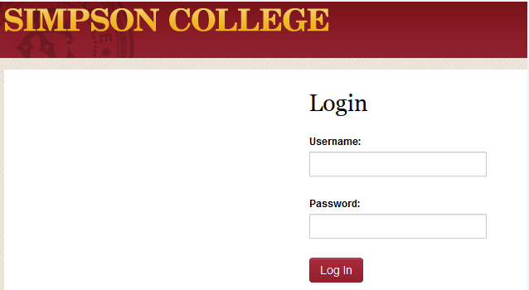

- Click on Create

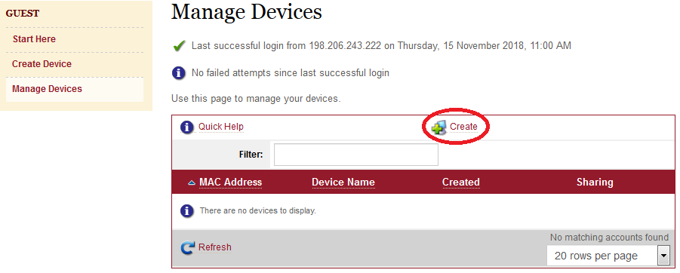

- Enter a name for the device and the MAC Address and then click on Create Device.

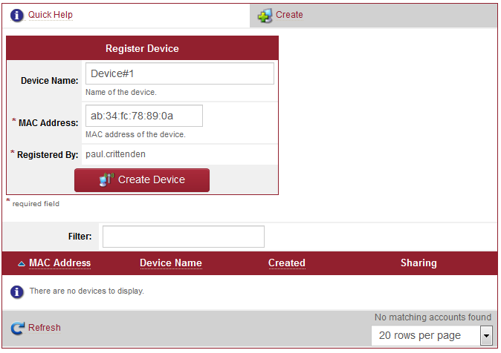

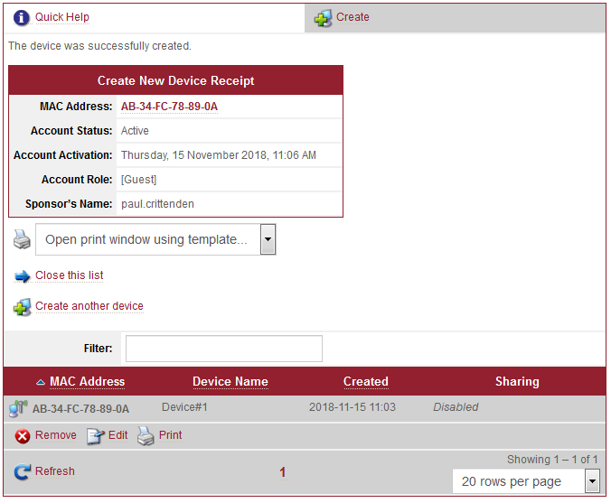

- Your device should be immediately available but please wait a couple of minutes.

- Connect your system to the wireless network, scdevices, and you should have connection to the internet. If you run into any issues please contact the helpdesk at 515-961-1411 or helpdesk@simpson.edu.

Below is a listing of how to find the MAC Address on several different devices.
Xbox 360-NXE
- Scroll Down (if necessary) to "My Xbox"
- Go all the way to the right and select "System Settings"
- On the new screen, select "Network Settings"
- Select "Configure Network"
- Under "Basic Settings" check to make sure "IP Settings" is on "Automatic"
- Go right to select the "Additional Settings" Tab
- Go down and select the second item "Advanced Settings"
- Towards the bottom of the screen you should see "Wired MAC Address." The MAC Address is the number below this.

Xbox 360
- Go right to reach the System "blade" of the Dashboard
- Select "Network Settings"
- Select "Edit Settings"
- Under "Basic Settings" check to make sure "IP Settings" is on "Automatic"
- Go right to get to the "Additional Settings" Tab
- Go down to select "Advanced Settings"
- Toward the bottom of the screen you should see "Wired MAC Adress". the MAC Address should appear below this.
Xbox One
- Go to the left of the screen where the icons are.
- Go down to the "Settings" icon (the gear towards the bottom).
- Select "All settings".
- Scroll down to "Network" and select "Network Settings".
- Go down to "Advanced Settings" and select it.
- Towards the right of the screen you will see Wired MAC and Wireless MAC. Note that the MAC addresses are different. Wired MAC is your MAC address for a wired conection using an Ethernet cable. Wireless MAC is for a wireless connection via SCDevices.
PlayStation 4
- Enter the "Settings" menu.
- Scroll down and select "Network".
- Go down and select "View Connection Status".
- Scroll down until you see MAC address (LAN Cable) and MAC address (Wi-Fi). Note that these MAC addresses are different. MAC address (LAN Cable) is for a wired connection and MAC address (Wi-Fi) is for a wireless connection.
PlayStation 3
- Power up the PlayStation 3 without any disc in the drive.
- Once the PlayStation 3 operating system has loaded, select "Settings," then "Network Settings."
- Select "Settings and Connection Status List" from the "Network Settings" menu.
- The physical address will be listed under "MAC Address."

PlayStation 2
- Power up the PlayStation 2 and load the Network Adaptor Startup Disc.
- Once it has loaded, select "ISP Setup" and press X on your controller.
- The ISP Setup will begin to load, and you will be presented with a license agreement. Select Agree and press X to continue.
- For connection type, choose "Local Area Network (LAN)" and press X to continue.
- Select "Automatic Configuration" and press X to continue.
- At the connection test screen, select "Advanced" and press X to continue.
- At the "Advanced Broadband Settings" screen, make sure "Automatic" is selected. While you are at this screen, make note of the MAC address at the bottom.
Some PS2 games also have the ability to list your MAC address, but the above steps are Simpson's preferred way of finding the MAC.
PSP
- Navigate to "System Settings"
- Then navigate to "System Information," which is where the MAC address is listed.
TiVo
- Open the Tivo menu.
- Select Settings.
- Select Phone/Network.
The MAC address will be listed on that screen along with the IP address.
Amazon Echo
- Download the Amazon Alexa app to your phone or computer and sign in with your Amazon account.
- Connect to the wireless network transmitted by your Echo device.
- The wireless MAC address for your Echo can be found at the bottom of the Echo Setup screen in the Alexa app.
Google Home
- Download and open the Google Home app on your phone.
- You should see your Google Home listed. Select it then press Set Up.
- Accept the prompt allowing your phone to connect to your Google Home.
- Answer the set up questions listed.
- Enter the location of your Google Home and select Continue
- The wireless MAC address will be listed at the bottom right corner of the screen.
Roku
- From the Roku home screen, select "Settings", then "Player Info."
- The wired MAC address is listed next to Ethernet MAC address. The wireless MAC address is listed next to Wireless MAC address.
Apple TV
- Plug in your Apple TV and follow the set up until you reach the step to connect to a network.
- Select cpvisitor and attempt to connect. This will fail, which is normal.
- The wireless MAC address should now be displayed on the Apple TV's screen.
Amazon Fire TV
- If this is the first time using this Fire TV device, the wireless MAC address will appear in the list of wireless networks during setup at the far-right of the list. If this Fire TV stick has been used in the past, navigate to Settings > System > About > Network.
- The wireless MAC address will be listed at this screen.

Getting Smart TV MAC Address

Insignia
To locate your Insignia Smart TV MAC address you will have to navigate to the Network settings. To navigate to the Network Settings follow these instructions:
- Press ENTER. The settings menu opens. (or press Menu)
- Press ▲ or ▼ to highlight Network, Then press ENTER.
- Press ▲ or ▼ to highlight Wired or Wireless, then press ENTER. (Note that the wired MAC address and the wireless MAC address are different)
  - The MAC address will be listed as either Ethernet Address or Wireless or WLAN MAC Address.
Samsung
To locate your Samsung Smart TV MAC address you will have to navigate to the Network settings. To navigate to the Network Settings follow these instructions:
- Press Menu.
- Press ▲ or ▼ to highlight Network, Then press ENTER.
- Press ▲ or ▼ to highlight Network Settings, Then press ENTER.
- Press ▲ or ▼ to highlight Wired or Wireless, then press ENTER. (Note that the wired MAC address and the wireless MAC address are different)
- Press ▲ or ▼ to highlight Network Test, then press ENTER.
  - The wired MAC address will be listed as either Ethernet Address or Wired MAC Address at the top of the screen.
Sharp
To locate your Sharp Smart TV MAC address you will have to navigate to the Network settings. To navigate to the Network Settings follow these instructions:
- Press the Menu on the remote.
- Press ◀ or ▶ to highlight Initial Setup, then press Enter.
- Press ▲ or ▼ to select Internet Setup, then press Enter.
- Press ▲ or ▼ to select Network Setup, then press Enter.
- Press ▲ or ▼ to select Connection Type, then press Enter.
- Press ◀ or ▶ to highlight Wired or Wireless, then press Enter.
- Press ▲ or ▼ to select IP Setup, then press
- The MAC Address should be on the bottom of the page.

Sony
To locate your Sony Smart TV MAC address you will have to navigate to the Network settings. To navigate to the Network Settings follow these instructions:
- Press the Home
- Use the arrow keys to scroll to Settings, then press Enter.
- Use the arrow keys to scroll to Network Setup, then press Enter.
- From the menu, select Wired or Wireless Setup, then press Enter.
- Click on Network Setup - Status and the MAC Address should be on the screen.

Vizio
To locate your Vizio Smart TV MAC addresses you will have to navigate to the Network settings. To navigate to the Network Settings follow these instructions:
- Press Menu on the remote.
- Press ▲ or ▼ to highlight the Network, then press OK.
- The Network Connection menu displays.
- Press ▲ or ▼ to highlight Manual Setup,Then press OK. The IP Settings menu is displayed.
- At the bottom of the menu the MAC addresses are displayed.
For any device not listed please Google how to find the MAC Address.

