Student Planning for Faculty

When you click on Search and Register in SC Connect, you are now taken to a landing page in Student Planning.
IT has created videos showing students how to use Student Planning.
For students who started at Simpson PRIOR TO the Fall of 2021: https://bit.ly/3EJCcf1
For students who started at Simpson in the Fall of 2021 or after: https://bit.ly/3VfIZ5G

This document is designed to help Foundations 1 faculty use the Advising tool within Student Planning.
Advising within Student Planning allows advisors to do things we couldn’t do before.
- You can see which courses students plan to take in the upcoming semester. That is, you can see a student’s “preferred list” although it is no longer called that.
- You can add courses to students’ planned schedules. You cannot register a student for a course, but you can add it to their “preferred list.” That means you should be careful when you are exploring Student Planning so that you do not accidentally add a course to a student’s plan.

Advising: View Details

Course Plan
Use > button to look at the courses the student plans to take in the upcoming semester. Click Calendar tab to change the view.
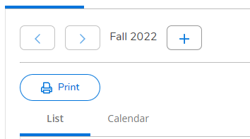
You can now see the courses the student is considering taking in the upcoming semester. Using the language of the previous system, this is the student’s preferred list. Notice that you can also see the number of seats currently available in each course.
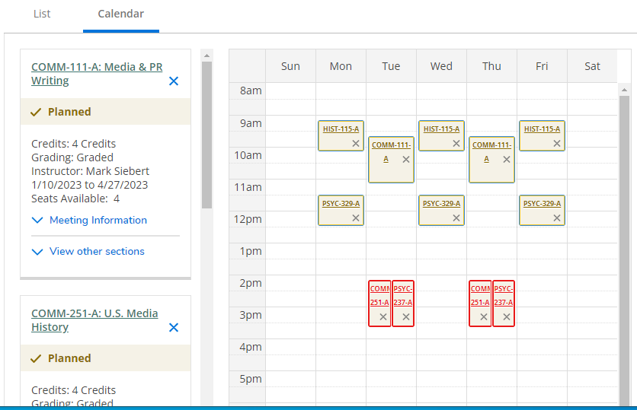
Equivalent of the Preferred List

Timeline
The timeline allows you to view the courses the student took each semester in the past and the courses they plan to take each semester in the future.

Progress (Advanced Version of Degree Audit)
This view shows the same information as the degree audit, but it provides additional capabilities. One important difference between Degree Audit and Progress is that Progress shows courses that students plan to take but are not yet registered for. Courses in-progress or completed are shown in green. Courses students are registered for or are planning to take are shown in yellow.
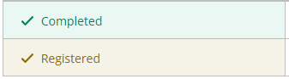
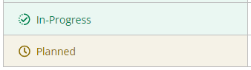
Each Simpson Core requirement (and each major requirement) has a search button. Clicking that button will take you to the Course Catalog and show all the possible courses that meet that requirement.
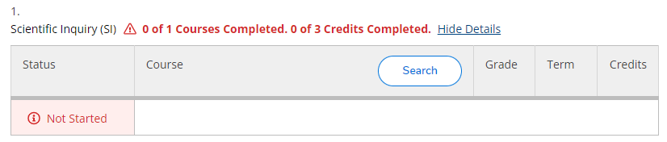
For example, clicking on Search for Scientific Inquiry might show the following:
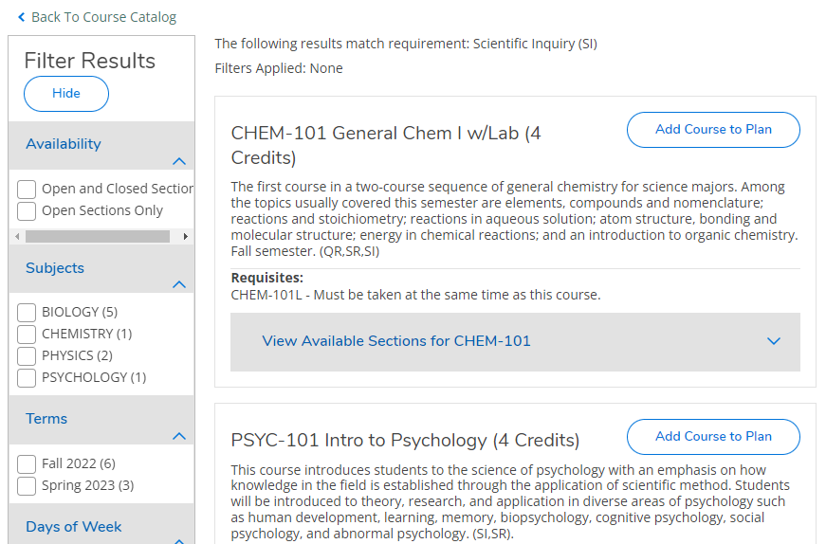
Notice that the results can be filtered to show only the courses offered in a given semester and with open sections.

Course Catalog
The course catalog tab within the Advisee Details view allows you to search for courses in a variety of ways. If you want to see what courses are offered in the Accounting department, click on Accounting. If you don’t want to scroll to the subject of interest, you can enter it in the search
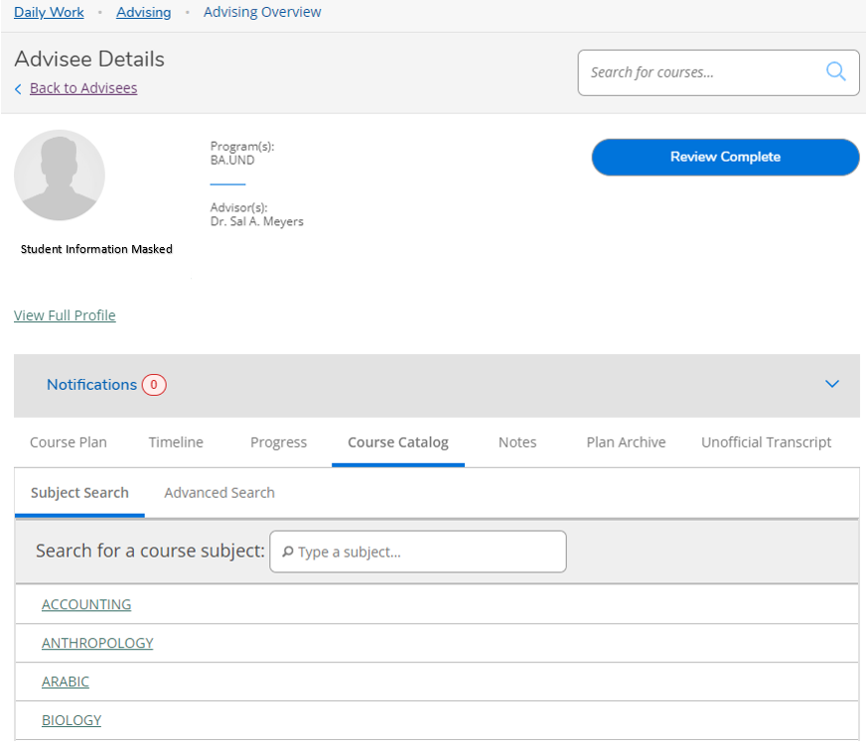
Allows you to search for courses by name or number
Allows you to search for subjects like Accounting, Anthropology, Arabic, and Biology. It does not allow you to search for course titles.

Once you have clicked on a subject or searched for a specific course, you will be able to access the filters.

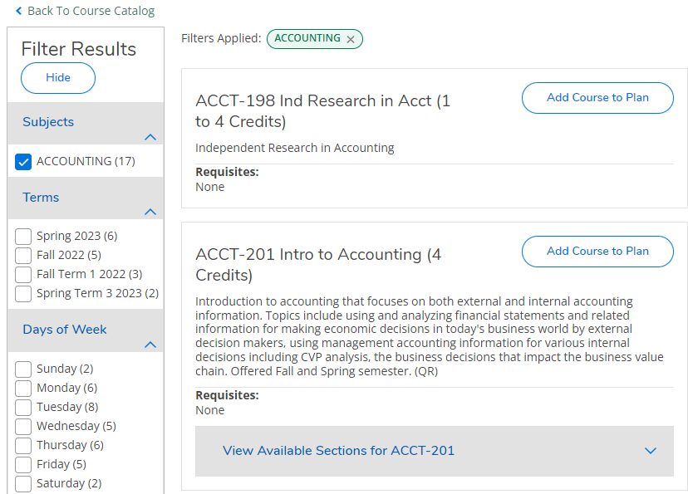
Use Filter Results to change the list of courses you see. If you remove the checkmark in front of Accounting, you can see all the subjects. Checking an item in the filter limits the courses to only those that are consistent with whatever you checked.
Filters are available for the following things:
- Subjects (e.g., Accounting, Chemistry, Criminal Justice, Education)
- Terms (e.g., Spring 2023, Fall Term 2 2022)
- Days of Week
- Time of Day
- Instructors
- Academic Levels (Undergraduate or Graduate)
- Course Types (e.g., general education designations)
When looking at course types, be careful not to confuse ECC designations with Simpson Core designations. Some of them look very similar.
ECC | Simpson Core
ARTS | ART & CREATIVE EXPRESSION
HISTRCL | HISTORICAL INQUIRY
ETHICS | ETHICAL DECISION MAKING
GLOBAL | GLOBAL STUDIES
SCIREASON | SCIENTIFIC INQUIRY

The Advanced Search option in the catalog allows you to search for different courses at the same time. For example, the following advanced search will show all the courses offered in the department of sociology and criminal justice in Spring 2023.
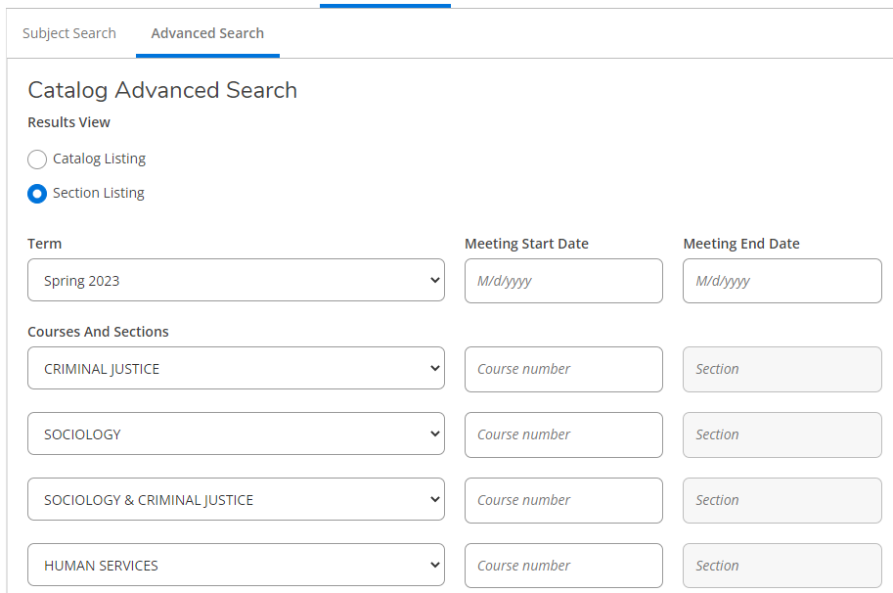
Courses can then be added to the student’s plan by clicking Add in front of each course the student wants to add to their preferred list.
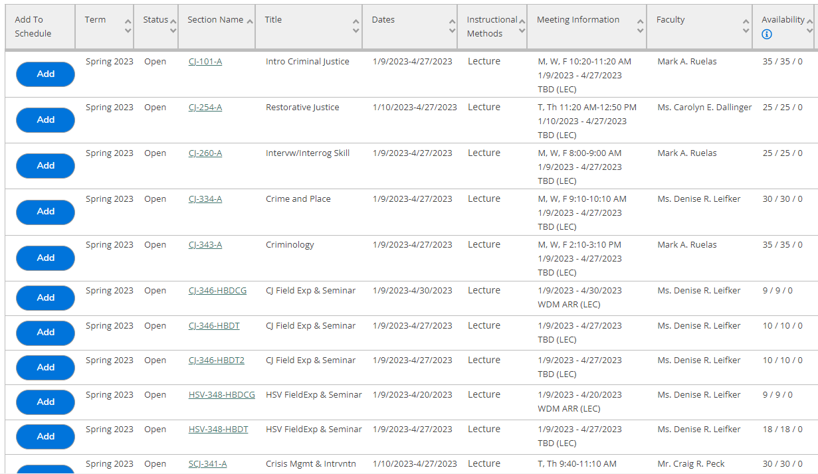
Courses versus Sections
Student planning allows for two different types of plans:
- plans used to register for specific courses, that is, creating a preferred list
- long-term planning, that is, creating a 4-year plan
The course catalog uses different buttons for these different types of plans. When preparing to register for the upcoming semester, students should use Add Section to Schedule. They should use Add Course to Plan when creating long-term plans.
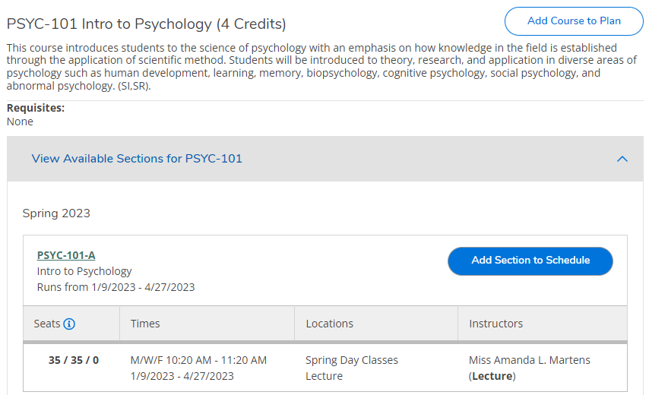

Notes
Notes cannot be deleted and are not private. I recommend waiting until we’ve learned more about this feature before using it. It’s designed to be a communication tool between students and advisors.

Approving Students for Registration
For now, we will continue to use “Approve Advisees for Registration” in SC Connect instead of Student Planning.

